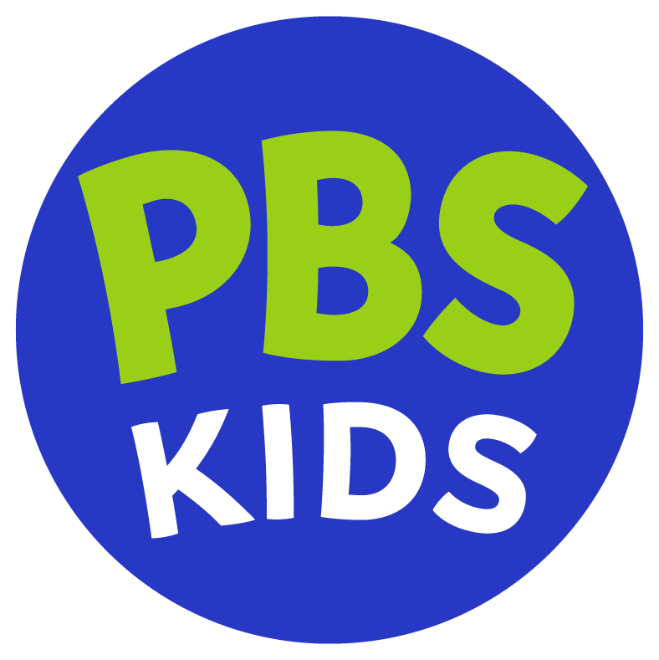
PBS KIDS Unveils New Logo
Refresh of iconic logo and expanded brand package reflect mission, ensure children see themselves reflected in brand and optimize for digital platforms of today and tomorrow
Arlington, VA, June 30, 2022 — PBS KIDS, the #1 educational media brand for children, announced today a comprehensive update to its logo for the first time in two decades. The new logo, set to debut on July 19, builds on an expanded graphics package that began rolling out last year, which features a bright updated color palette and an array of people and environments. The refreshed look is designed to build on the equity and strength of the PBS KIDS brand and optimized for today’s digitally-focused kids and families.
Audiences will see a new text-focused logo dominated by bright, fun colors, large bold lettering and clear visuals. With feedback from parents, kids, and experts in the field, the logo’s use of PBS KIDS text only reinforces the beloved, trusted and familiar brand name and signals fun, safe, educational content for families. The new logo’s colors, including PBS’ blue and PBS KIDS’ green, combined with the style of the iconography, are also designed to complement the iconic PBS brand.
Complementing the logo redesign, PBS KIDS recently worked on an expansion to its brand package that is reflective of the kids and families they serve. The creative includes a vibrant color pallet with combinations that conform with accessibility standards, whimsical typography, engaging design elements, and new visuals of people and places that bring a diversity of culture, race, ethnicity, geography, family structure, varying abilities, body type, and more to the PBS KIDS visual world. The approach was to build on the existing graphics package, adding new friends to join PBS KIDS’ longstanding animated kids Dot, Del and Dee as part of one welcoming PBS KIDS world.
“We’re thrilled to unveil our new logo and branding updates, which are meant to bolster the PBS KIDS mission by continuing to reflect and reach our audience in a multiplatform environment,” said Sara DeWitt, Senior Vice President & General Manager, PBS KIDS. “Our new logo is fun, welcoming and bright, and resonates with kids and parents as a new look for the PBS KIDS brand that they love and trust.”
PBS KIDS worked with Lippincott, a global creative consultancy, to develop the new logo.
The new PBS KIDS logo and expanded brand package may be viewed HERE.
About PBS KIDS
PBS KIDS believes the world is full of possibilities, and so is every child. As the number one educational media brand for kids, PBS KIDS helps children ages 2-8 learn lessons that last a lifetime. Through television, digital media, and community-based programs, PBS KIDS wants children to see themselves uniquely reflected and celebrated in lovable, diverse characters who serve as positive role models, and to explore their feelings and discover new adventures along the way. Families can watch PBS KIDS anytime on the free PBS KIDS 24/7 channel and the PBS KIDS Video app, available on mobile and connected-TV devices, no subscription required. PBS KIDS’ large collection of mobile apps and pbskids.org provide accessible content, including digital games and streaming video to spark kids’ curiosity. PBS KIDS and local stations across the country support the entire ecosystem in which children learn and grow – including their teachers, parents, and community – providing resources to support children’s learning, anytime and anywhere. For more information, visit pbs.org/pressroom, or follow PBS KIDS on Twitter, Facebook and Instagram.

