ELINOR WONDERS WHY Biographies

Jorge Cham (Co-Creator/Executive Producer)
Jorge Cham is the cartoonist behind the popular online comic “Piled Higher and Deeper” (a.k.a. PHD Comics). He holds a PhD in Robotics from Stan- ford University and is a former Instructor and Research Associate at Caltech. His work as a researcher focused on Biomimetic Design and Neural Implants.

Daniel Whiteson (Co-Creator/Executive Producer)
Daniel Whiteson is a professor of physics at the University of California, Irvine, and a fellow of the American Physical Society. He earned his PhD in Physics from the University of California at Berkeley and is an active researcher, using the Large Hadron Collider at CERN to search for exotic new particles.

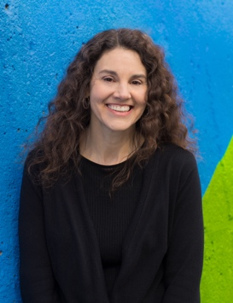
Linda Simensky (Head of PBS KIDS Content)

As the Head of PBS KIDS Content, Linda Simensky collaborates with producers, co-production partners, PBS station programmers, and distributors throughout the development, production, post-production, broadcast and digital phases for PBS KIDS content. She leads the development of a multi-platform video content strategy, designed to respond to the quickly evolving media environment and meet the needs of current and future viewers. She spearheads new, experimental approaches for emerging platforms to engage kids and support their learning, developing a slate of content that represents the next generation of children.
Linda’s efforts in transforming PBS KIDS’ lineup for children over the past several years have brought PBS to the forefront of the children’s media space. The American public rates PBS KIDS as the most trusted educational media brand for children, and PBS KIDS programs consistently rank highly with moms and preschoolers. PBS KIDS has been named Channel of the Year in Kidscreen’s broadcasting awards for five out of the past seven years.
Since joining PBS in 2003, Linda has worked with renowned producers to develop hit shows that now reach 72% of all kids ages 2-8 in the U.S. – from DANIEL TIGER’S NEIGHBORHOOD and DINOSAUR TRAIN, to WILD KRATTS and ODD SQUAD.
Before joining PBS, Linda was Senior Vice President of Original Animation for Cartoon Network, where she oversaw development and series production of "The Powerpuff Girls," among others. She began her career working for nine years at Nickelodeon, where she helped build the animation department and launch the popular series "Rugrats," "Doug" and "The Ren & Stimpy Show." Linda is a frequent speaker and writer on the topic of children’s programming; she has presented at numerous animation and television conferences and her work has appeared in several books on animation and children’s media. She also teaches a course on “Contemporary Issues in Animation” at the University of Pennsylvania.

