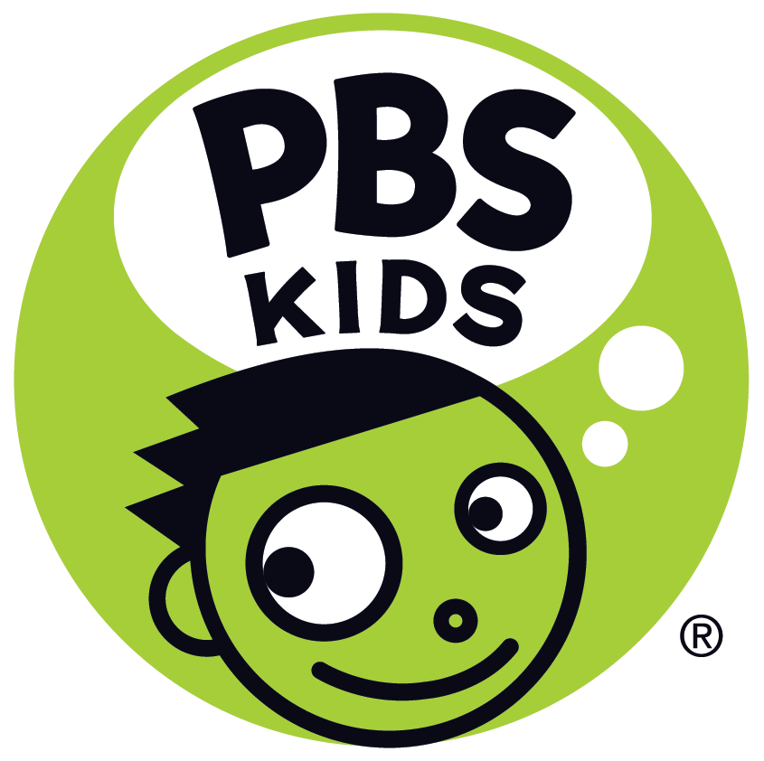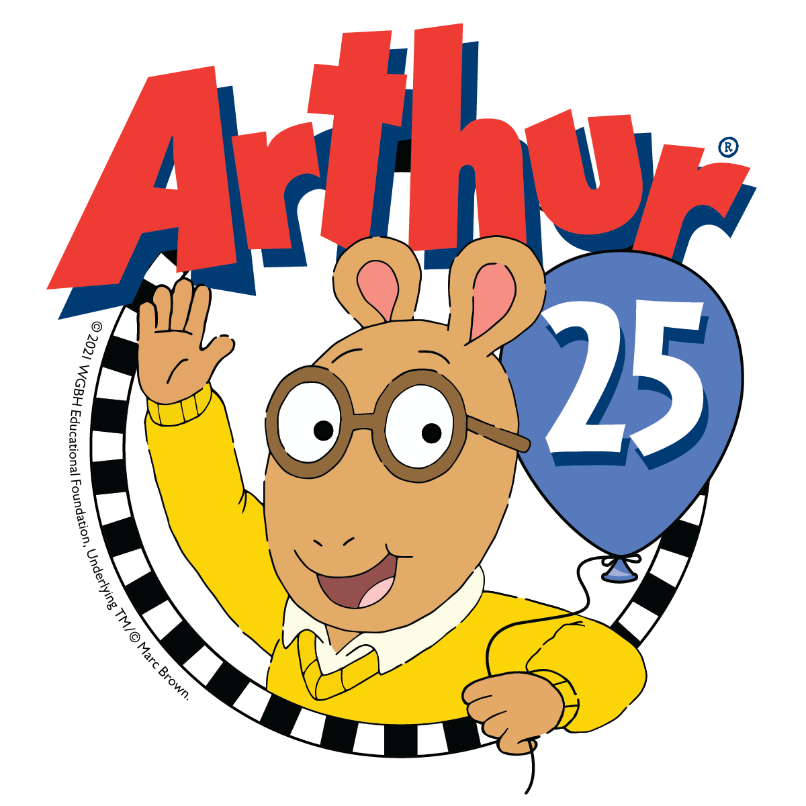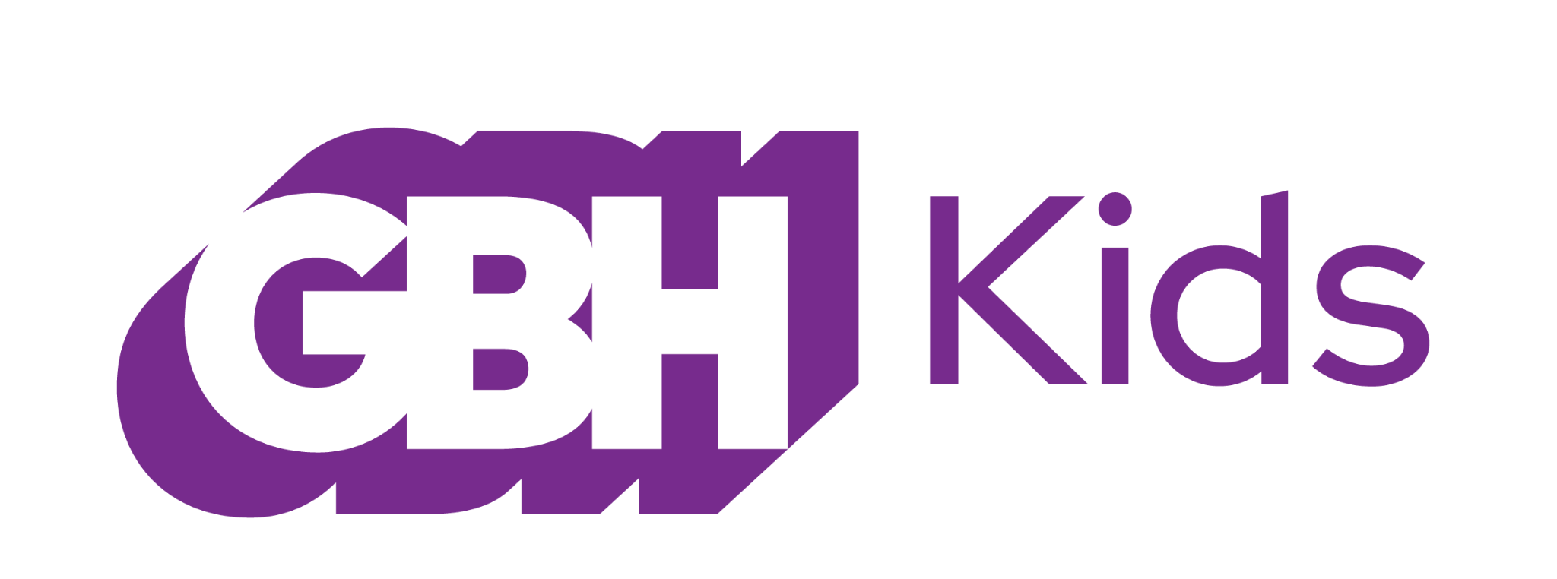

ARTHUR Celebrates 25th Anniversary on PBS KIDS with Special Marathon and Big Reveal: The Beloved Characters Grow up

Iconic Series Produced by GBH Kids to Continue to Launch New Content this Year and Beyond, Including Podcast, Topical Shorts, and Games
ARLINGTON, VA, January 18, 2022 – PBS KIDS and GBH Kids today announced that ARTHUR, the iconic Peabody and Emmy Award-winning® series based on the bestselling books by Marc Brown, will celebrate its 25th anniversary with a special marathon, including four new episodes, which culminate in a much-anticipated ending that gives a glimpse into what’s in store for the future of these beloved characters. The marathon will feature more than 250 episodes and movie specials back-to-back on the PBS KIDS 24/7 channel and livestream, as well as on the PBS KIDS YouTube channel from February 16 at 9:00 a.m. EST to February 21 at 5:00 p.m. EST. The four brand-new episodes will air on PBS stations (check local listings) and stream free on PBS KIDS on February 21, concluding the show’s 25th and final television season.

New content from ARTHUR will continue rolling out in 2022 and beyond, including a podcast, video shorts that tackle timely and compelling topics, and digital games. The 25 seasons of ARTHUR (250+ episodes) will continue to be available on PBS KIDS.

“For more than 25 years, Arthur and his friends have kept viewers learning and growing through their true-to-life experiences,” said Sara DeWitt, Senior Vice President and General Manager, PBS KIDS. “We can’t wait to debut these episodes and introduce new ARTHUR content that will give fans more ways to engage with their favorite aardvark.”

ARTHUR is the longest-running kids’ animated series on television and is known for teaching kindness, empathy, and inclusion through everyday adventures and many groundbreaking moments. In the new episodes, Arthur and his friends solve a mystery, see a silent movie, find out what it’s like to be a reporter, learn how to help a grieving friend, go on a family vacation, and get a hint of their futures from a mysterious fortune-telling game.

It’s been a privilege to work with an extraordinary and talented team to bring to Arthur to public television audiences for more than two decades, “said Carol Greenwald, Senior Executive Producer, GBH Kids. “We’re excited about Arthur’s next chapter – sharing the stories and experiences of Arthur and his Elwood City community to the media platforms where the next generation of kids and families will connect with them for years to come.”

Marc Brown, the author of the "Arthur Adventure" book series, which has sold more than 65 million copies in the U.S. alone, is also releasing a new book, "Believe in Yourself: What We Learned from Arthur" (Little, Brown Books for Young Readers), on January 25, 2022.

“It’s amazing that what began as a simple bedtime story for my son eventually evolved into over a hundred books and a collaboration with GBH and PBS KIDS that would last 25 years,” said Marc Brown the creator and author of ARTHUR. “Now more than ever the last line of my first book Arthur’s Nose rings true- ‘There is a lot more to Arthur than his nose.’”

Since its inception, ARTHUR has tackled many important, timely topics. In 2020, GBH Kids created a series of digital short videos to give parents and families tools to talk about current events – including the importance of hand-washing and wearing a mask; talking about racism; and encouraging everyone to participate in elections. Over the next several years, the team will produce additional new shorts to address timely topics families will be facing as well as everyday Elwood City adventures.

ARTHUR will also create new content for other platforms. GBH Kids will partner with Gen-Z Media for a new podcast, which will leverage ARTHUR’s incomparable library of stories, favorite characters, and heartfelt moments that have strongly resonated with audiences to create engaging audio content that reaches existing fans, as well as help introduce a new generation to the series and some of its classic storylines. This podcast will be available on podcast streaming platforms and on pbskids.org.

New interactive ARTHUR games will also launch on pbskids.org and the PBS KIDS Games app.

About ARTHUR
ARTHUR, based on the best-selling books by Marc Brown, is television’s longest- running children’s animated series. For 25 seasons, ARTHUR has remained one of the most popular and beloved weekday children’s series on PBS. Easily recognized by its timeless and joyful theme song, the iconic, award winning PBS Kids series has touched audiences around the world with its heartfelt and humorous stories about family, friends, and the challenges of growing up. ARTHUR is produced by GBH Boston and Oasis Animation, Inc. Funding for ARTHUR is provided by public television viewers. Corporate funding is provided by ABCmouse.com and IKEA Retail U.S. For more information, visit pbskids.org/Arthur and follow ARTHUR on Facebook, Instagram and Twitter.

About PBS KIDS
PBS KIDS believes the world is full of possibilities, and so is every child. As the number one educational media brand for kids, PBS KIDS helps children ages 2-8 learn lessons that last a lifetime. Through media and community-based programs, PBS KIDS wants children to see themselves uniquely reflected and celebrated in lovable, diverse characters who serve as positive role models, and to explore their feelings and discover new adventures along the way. Families can stream PBS KIDS for free anytime, no subscription required. A large collection of mobile apps and pbskids.org provide accessible content that spark kids’ curiosity. PBS KIDS and local stations across the country support the entire ecosystem in which children learn and grow – including their teachers and caregivers, parents, and community – providing resources accessible anytime and anywhere. For more information, visit pbs.org/pressroom, or follow PBS KIDS on Twitter, Facebook and Instagram.

About GBH Kids
GBH Kids is one of the top producers for public media, creating educational content for kids, parents, caregivers and teachers, including iconic PBS Kids programs such as the award-winning Arthur and Molly of Denali, digital series such as Scribbles and Ink, games, apps and podcasts. GBH Kids, based in Boston, also works closely with PBS LearningMedia, providing digital curricula for more than 2 million teachers across all 50 states. GBH Kids is committed to equity and access to educational media and the healthy development of all children. As the inventor of closed captioning and audio description, GBH is dedicated to making media accessible and inclusive. Find more information at gbh.org/kids

###
Media Contacts:
PBS | Lubna Abuulbah | labuulbah@pbs.org
Grand Communications | Gabrielle Torello | gab@grandcommunications.com

