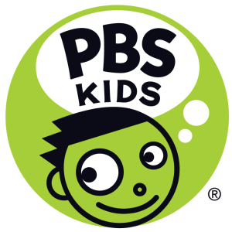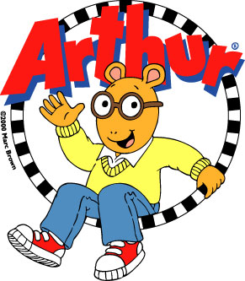

NEW ARTHUR APP FROM PBS KIDS ENCOURAGES POSITIVE SOCIAL SKILLS

Now Available on the App Store, Arthur’s Big App helps children explore collaboration, friendship and teamwork

ARLINGTON, VA, September 25, 2014 – PBS KIDS today announced the launch of Arthur’s Big App for iPhone, iPad and iPod touch, a new app inspired by the hit series ARTHUR. Designed for children ages 6-8, Arthur’s Big App encourages positive social skills through fun and engaging multi-level games. Focusing on the values of friendship, teamwork and helping others, each game allows kids to explore Elwood City and interact with their favorite ARTHUR characters.

“PBS is committed to using the power of digital media to educate and inspire,” said Ira Rubenstein, Senior Vice President and General Manager, Digital, PBS. “As part of fulfilling this mission, PBS offers more than 40 apps for kids and parents. With engaging games and popular ARTHUR characters, Arthur’s Big App leverages the educational potential of touchscreen technology to help children develop the teamwork and collaboration skills that will prepare them for success in school and in life.”

Based on the beloved ARTHUR series, which airs weekdays on PBS KIDS and is produced by WGBH, Arthur’s Big App offers the following features:

- Four unique mini-games hosted in memorable locations around Elwood City
- More than 15 levels per game
- Randomization of gameplay to keep kids engaged
- 50 collectable characters from throughout the history of the series
- A music game in which kids can enjoy a variety of well-known tunes, including the ARTHUR theme song
- A smoothie game in which kids create delicious treats for Sugar Bowl customers
- A library game that challenges kids to find and shelve books before time runs out
- A freeze tag game in which kids “freeze” ARTHUR characters – a fun, digital twist on a classic playground game

Arthur’s Big App launches just in time for the premiere of ARTHUR’s 18th season on PBS KIDS. Starting Monday, September 29, families can join Arthur and his friends for a week of new adventures that explore childhood challenges with heart and humor, while teaching problem-solving and pro-social skills. The fun continues on the ARTHUR website, where kids, parents, caregivers and teachers can access a variety of fun and educational games, lesson plans, and activities.

Arthur’s Big App is part of PBS KIDS’ ongoing commitment to help kids learn through educational media. The organization offers a variety of apps to help build school readiness skills. More information on PBS KIDS apps is available at pbskids.org/apps.

Arthur’s Big App is available for $2.99 on the App Store for iPhone, iPad and iPod touch or at www.AppStore.com/PBSKIDS.

Images of Arthur’s Big App are available on PBS PressRoom.

About PBS KIDS
PBS KIDS, the number one educational media brand for kids, offers all children the opportunity to explore new ideas and new worlds through television, online, mobile and community-based programs. Kidscreen- and Webby-award winning pbskids.org provides engaging interactive content, including the PBS KIDS video player, now offering free streaming video accessible on computer- and mobile-device-based browsers. For more information on specific PBS KIDS content supporting literacy, science, math and more, visit pbs.org/pressroom or follow PBS KIDS on Twitter and Facebook.

About ARTHUR
ARTHUR, based on the best-selling books by Marc Brown, is television’s longest-running children’s animated series. Over the past 17 seasons, ARTHUR has remained one of the highest-rated weekday children’s series on PBS among children 4-8. ARTHUR has won numerous awards, including the George Foster Peabody Award, a BAFTA and seven Daytime Emmys®-four for Outstanding Children’s Animated Program. ARTHUR is produced by WGBH Boston and 9 Story Entertainment. Executive producers are Carol Greenwald (WGBH), Vince Commisso (9 Story) and Marc Brown (Marc Brown Studios). Directed by Greg Bailey. Funding for Arthur is provided by public television viewers. Corporate funding is provided by Chuck E. Cheese’s®. For more information, visit pbskids.org/arthur and follow ARTHUR on Facebook and Twitter.
About WGBH
WGBH Boston is America’s preeminent public broadcaster and the largest producer of PBS content for TV and the web. Television channels include WGBH 2, WGBX 44, and the digital channels World and Create. WGBH Radio serves listeners across New England with 89.7 WGBH Boston Public Radio; 99.5 WCRB; and WCAI, the Cape and Islands NPR® Station. Find more information at wgbh.org.
Contacts:
Atiya Frederick, PBS; 703-739-5147; anfrederick@pbs.org
Mandy Miller, WGBH; 617-300-5334; mandy_miller@wgbh.org
Meredith Gandy, 360 PR; 415-610-4067; mgandy@360pr.com

# # #

