25 Years of ARTHUR…And Beyond
Winter 2022 TCA Bios
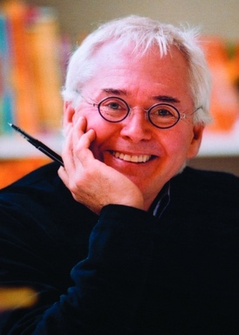
Marc Brown, Author and Co-Executive Producer, ARTHUR
Marc Brown is the creator of the bestselling Arthur Adventure book series and creative producer of the number-one children’s PBS television series “Arthur.” He has illustrated many books for children, including Marc Brown’s Playtime Rhymes, If All the Animals Came Inside, Ten Tiny Toes, and Wild About Books. He divides his time between Martha’s Vineyard and New York City.

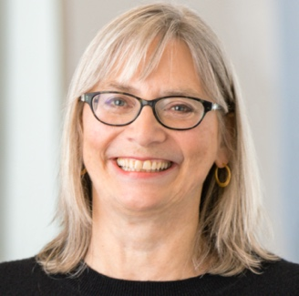
Carol Greenwald, Executive Producer, ARTHUR, GBH Kids
Carol Greenwald is Director of Children’s Media at GBH, Boston where she has produced some of the best-loved children’s shows on television.

In her capacity of Director of Children’s Media, she manages a talented team who are currently producing and developing multiple broadcast and digital series including the Emmy®-nominated Scribbles & Ink and The Ruff Ruffman Show (for the PBS KIDS digital channel); Pinkalicious & Peterrific, and the Peabody Award-winning Molly of Denali (for PBS KIDS broadcast channel).

She co-developed and is Executive Producer for the multiple Emmy and Peabody Award-winning Arthur, now the longest running children’s animated series on television throughout its more than 22-year run. She also co-developed and was executive producer for Curious George, Martha Speaks, Postcards from Buster, and Time Warp Trio (which aired on the Discovery Kids block on NBC). As Executive Producer of these series, Greenwald oversaw the creative development and production of the television programs, and supervised ancillary activities such as the Web site and educational outreach.

Ms. Greenwald was one of the original creators of the TV series Long Ago & Far Away, and alternately served as its project director, series editor, and producer. Before working in children’s programming, she was project director of two tele-courses for high school and college level students: The Western Tradition and French in Action.
Daniel Brochu, voice of “Buster Baxter,” ARTHUR
Daniel is a Canadian voice, theatre, tv and film actor from Montreal. He has been the voice of Buster Baxter from the very beginning. He is the father of two teenage boys, the owner of a Pug named Violet, and he loves growing garlic in his back garden. He is very proud to be a small part of the PBS family.

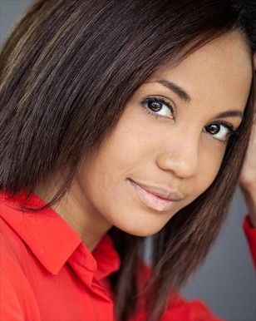
Jodie Resther, voice of “Francine Frensky,” ARTHUR
Jodie Lynn Resther is a Canadian actress, voice actor and singer with a more than two- decade long career in the entertainment industry. From playing on Sesame Street at the tender age of 5 to her most accomplished projects to date such as:

- Playing the character of Kiki on Nickelodeons Are you Afraid of the dark?
- Voicing the character of Francine Frensky on the iconic Emmy awarding winning children’s series Arthur...
- Nurse Rachel alongside Bruce Willis in Deathwish Jodie truly has an acting career to be
proud of.

Her music career has also been a successful journey as Jodie recorded three albums with
French Canadian label Déja Musique and Universal (ULM) in Europe and Canada. Jodie also toured with iconic musical groups such as Backstreet boys and TLC. The revolutionary year of 2022 ahead will no doubt usher in a fresh wave of projects for this talented young performer who is continuing to grow to new heights, pushing her talents further.

