MEDIA CONTACTS:
Erin Callanan Brandii Toby-Leon, Bullseye Communications
erin_callanan@wgbh.org brandii.leon@bullseyecomm.com
617-905-6866 865-963-2418

Frederick Wiseman’s 44th Feature Film
MENUS-PLAISIRS - LES TROISGROS
to Premiere March 22 on PBS
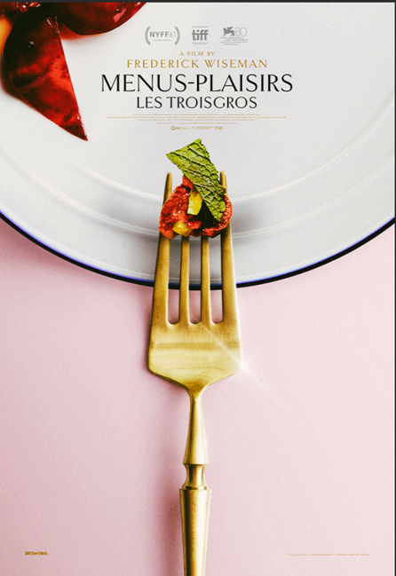
BOSTON, MA; Feb. 6, 2024 – Legendary documentary filmmaker Frederick Wiseman’s latest film, MENUS-PLAISIRS - LES TROISGROS, is guaranteed to please fans of documentaries, food, family sagas, and travel. The film will premiere March 22 at 9 p.m. ET (check local listings) on PBS, PBS.org, and the PBS App, with the film available for early streaming starting March 1.

Presented by Boston’s public media producer GBH, the Zipporah Films release follows the Troisgros family in central France and their three restaurants. MENUS-PLAISIRS – LES TROISGROS was selected as the best non-fiction film of 2023 by the New York, Los Angeles, and National Film Critics Associations.

“The words ‘Wiseman’ and ‘documentary’ have been synonyms since his first film more than 60 years ago. His films have been a mainstay of public media for 54 years, since the earliest days of public broadcasting,” said John Bredar, vice president for national programming at GBH. “We are thrilled to be presenting his latest masterpiece, MENUS-PLAISIRS – LES TROISGROS. It is an intimate glimpse into how exquisite craftsmanship, artistry, creativity, and collaboration define this culinary institution.”

The MENUS-PLAISIRS – LES TROISGROS is a film about the Troisgros family and their restaurants, Troisgros, Le Central, and Colline de Colombia, located in three neighboring locations in central France. Much of the film takes place near Roanne at Troisgros, where the present chef, César Troisgros, is the fourth generation of the family to be in charge. Founded 93 years ago, the restaurant has maintained three Michelin stars for 55 years. The film explores the day-to-day operations of this restaurant, from purchasing fresh vegetables at the market, visits to a cheese processing plant, a vineyard, a cattle ranch working on best farming practices, and an organic farmer whose farm, along with the garden of the restaurant, provides organic produce for the restaurants.

The film shows the great artistry ingenuity, imagination, and hard work of the restaurant staff in creating, preparing, and presenting meals of the highest quality. Characterized by his signature long-form style, Wiseman juxtaposes the choreographed chaos of the kitchen with pastoral shots of the French countryside, resulting in a comprehensive portrait of the Troisgros dynasty.

“A film about a restaurant aligns with my institutional series and making a film about a 3-star Michelin restaurant has always been one of my fantasies,” said Wiseman. “While visiting Burgundy in the summer of 2020, I had lunch with friends at Troisgros. After the meal, I spontaneously asked Chef César Troisgros if he would consider a documentary film about his restaurant, which started the incredible journey of producing this film.”

Throughout the film, the family’s interest in biodiversity is illustrated in their choice and preparation of their distinctive menu and their efforts to reduce food waste. Additionally, the collaboration within the Troisgros family is evident as the father, Michel, ponders the transfer of leadership in the kitchen to his son and collaborates with his wife, who runs the hotel, and his other son who runs La Colline de Colombia.

MENUS-PLAISIRS - LES TROISGROS is a film by Frederick Wiseman. Producer, Director, Editor Frederick Wiseman, photography James Bishop, sound Jean-Paul Mugel, producers Karen Konicek & Oliver Giel. Produced by 3 Star LLC in association with Zipporah Films, GBH, and the Independent Television Service (ITVS), with funding provided to ITVS by the Corporation for Public Broadcasting. The film was made possible by JustFilms Ford Foundation and Pershing Square Foundation. Fiscal sponsor Filmmakers Collaborative.

MENUS-PLAISIRS - LES TROISGROS premieres on PBS March 22 at 9 p.m. ET (check local listings). The documentary will also be available to stream for free from March 1- April 20 on PBS.org and the PBS App. Follow on social media at #WisemanPBS or on Facebook, X (formerly Twitter), and Instagram. For more information, visit pbs.org/menusfilm.

About Frederick Wiseman
Frederick Wiseman is a film and theater director of 44 feature-length documentaries and two fiction films. In 2019, he was the honoree of the Library Lions Award from the New York Public Library and received the Pennebaker Award for Lifetime Achievement at the Critics’ Choice Documentary Awards. In 2018, he was the Charles Eliot Norton Professor of Poetry at Harvard University. In 2016, he received an Honorary Award for lifetime achievement from the Academy of Motion Picture Arts and Sciences Board of Governors. He is a MacArthur Fellow, a Fellow of the American Academy of Arts and Sciences, the recipient of a Guggenheim Fellowship, and an Honorary Member of the American Academy of Arts and Letters. He has won numerous awards, including four Emmys. In recent years, he directed “The Belle of Amherst,” “Beckett’s Happy Days,” and Vasily Grossman’s “The Last Letter” at the Comédie-Française in Paris and Theatre for a New Audience in New York. A ballet inspired by his first film, “Titicut Follies” (1967), premiered at the New York University Skirball Theater in 2017.

About GBH
GBH is the leading multiplatform creator for public media in America. As the largest producer of content for PBS and partner to NPR and PRX, GBH delivers compelling experiences, stories and information to audiences wherever they are. GBH produces digital and broadcast programming that engages, illuminates and inspires, through drama and science, history, arts, culture and journalism. It is the creator of such signature programs as MASTERPIECE, ANTIQUES ROADSHOW, FRONTLINE, NOVA, AMERICAN EXPERIENCE, Arthur and Molly of Denali and a catalog of streaming series, podcasts and on-demand video. GBH’s television channels include GBH 2, GBH 44, GBH Kids and national services WORLD and Create. With studios and a newsroom headquartered in Boston, GBH reaches across New England with GBH 89.7, Boston’s Local NPR; CRB Classical 99.5; and CAI, the Cape and Islands NPR station. Dedicated to making media accessible to and inclusive of our diverse culture, GBH is a pioneer in delivering media to those who are deaf, hard of hearing, blind and visually impaired. GBH creates curriculum-based digital content for educators nationwide with PBS LearningMedia and has been recognized with hundreds of the nation’s premier broadcast, digital and journalism awards. Find more information at gbh.org.

About PBS
PBS, with more than 330 member stations, offers all Americans the opportunity to explore new ideas and new worlds through television and digital content. Each month, PBS reaches over 42 million adults on linear primetime television, more than 15 million users on PBS-owned streaming platforms, and 56 million people view PBS content on social media, inviting them to experience the worlds of science, history, nature, and public affairs; to hear diverse viewpoints; and to take front-row seats to world-class drama and performances. PBS’s broad array of programs has been consistently honored by the industry’s most coveted award competitions. Teachers of children from pre-K through 12th grade turn to PBS LearningMedia for digital content and services that help bring classroom lessons to life. As the number one educational media brand, PBS KIDS helps children 2-8 build critical skills, enabling them to find success in school and life. Delivered through member stations, PBS KIDS offers high-quality content on TV — including a PBS KIDS channel — and streaming free on pbskids.org and the PBS KIDS Video app, games on the PBS KIDS Games app, and in communities across America. More information about PBS is available at PBS.org, one of the leading dot-org websites on the internet, Facebook, Instagram, or through our apps for mobile and connected devices. Specific program information and updates for press are available at pbs.org/pressroom or by following PBS Communications on X (formerly Twitter).

