JOHN LEWIS – GET IN THE WAY,
First Documentary Biography of the Civil Rights Hero and
Congressional Leader, Premieres Friday, February 10 on PBS

(ATLANTA, GA – JANUARY 17, 2017) — PBS and Georgia Public Broadcasting announced today that JOHN LEWIS – GET IN THE WAY, a new documentary produced and directed by Kathleen Dowdey, will premiere Friday, February 10, 2017, 10:30-11:30 p.m. ET (check local listings) on PBS. The first documentary biography of Lewis, whose unwavering fight for justice spans the past 50 years, is part of Black History Month programming on PBS. The son of sharecroppers, Lewis grew up in rural isolation, seemingly destined for a bleak future in the Jim Crow South. But Lewis took a different path, rising from Alabama’s Black Belt to the corridors of power on Capitol Hill, his humble origins forever linking him to those whose voices often go unheard.
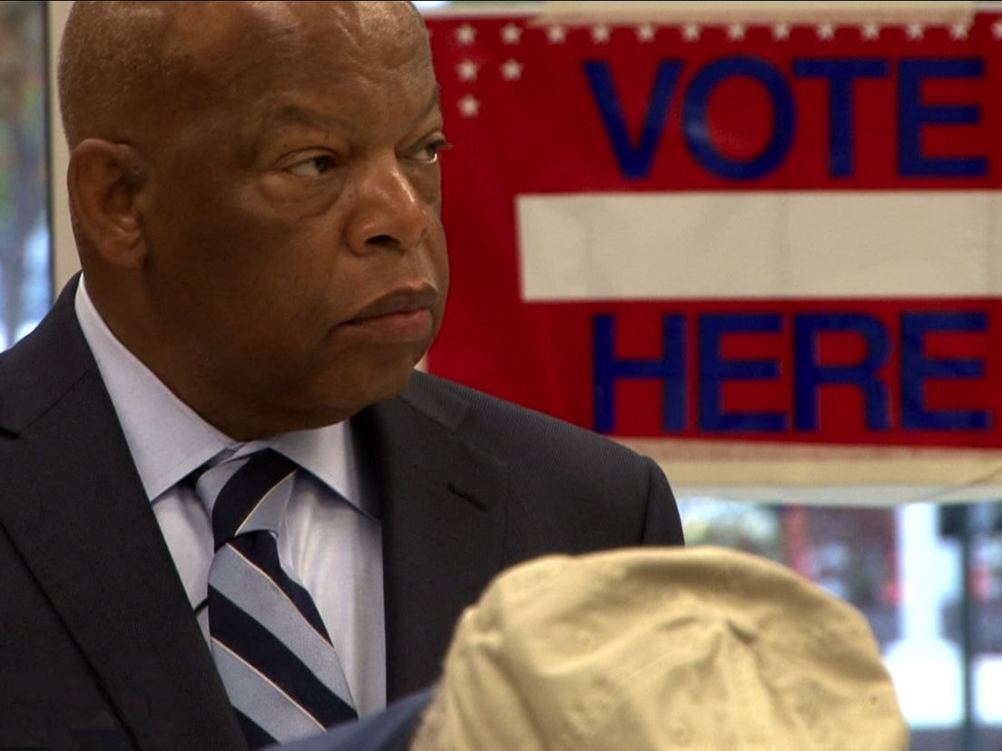Credit: Early Light Productions

JOHN LEWIS – GET IN THE WAY spans more than half a century, tracing Lewis’ journey of courage, confrontation and hard-won triumphs. At the age of 15, his life changed forever when he heard Dr. Martin Luther King, Jr. on the radio. It was 1955, during the Montgomery Bus Boycott, and Lewis listened with rapt attention as the young preacher called for nonviolent resistance to the harsh injustice of segregation. Lewis embraced Dr. King’s spiritual call with a fervor that would transform the course of his life.

As a student activist in the vanguard of the civil rights movement, Lewis was arrested and jailed for the first time during the Nashville lunch counter sit-ins in 1960. During the 1961 Freedom Rides, he was repeatedly assaulted by angry mobs. He was the youngest speaker at the historic 1963 March on Washington, and in March 1965, Lewis led the Bloody Sunday march in Selma, Alabama, where state troopers attacked peaceful protesters with billy clubs, bullwhips and tear gas. Their horrific actions were broadcast on news reports into living rooms across America; eight months later, the Voting Rights Act was signed into law.

Following a film festival run and featuring never-before-seen interviews shot over 20 years, JOHN LEWIS – GET IN THE WAY features Lewis, a masterful storyteller, relating the gripping tale of his role in these history-making events. Other key interviewees include civil rights activists Andrew Young, C.T. Vivian, Juanita Abernathy and Bernard Lafayette, as well as Lewis’ congressional colleagues Eleanor Holmes Norton, Nancy Pelosi, Harry Reid, Emanuel Cleaver and Amory Houghton.

“Atlanta and the state of Georgia have played a pivotal role in the civil rights movement,” said Georgia Public Broadcasting President and CEO Teya Ryan. “Through the years we've shared the stories of many of the movement’s greatest heroes with Georgia ties, including Martin Luther King Jr. and Andrew Young. We are thrilled to bring a film that so eloquently captures the legacy of John Lewis to a national audience through PBS.”

Once an activist pushing from the outside, Lewis, now 76 years old, has become a determined legislator creating change from the inside. Considered by many to be the conscience of Congress, with equal measures of modesty and forcefulness, Lewis strives to persuade D.C. powerbrokers to hear the voices of the unheard. He fights for those suffering from discrimination, poverty, poor education, police brutality, inaccessible healthcare and limitations on voting rights. Despite setbacks — and there have been many — John Lewis’ eyes remain on the prize.

JOHN LEWIS – GET IN THE WAY airs as part of a full line-up of Black History Month programming on PBS, which celebrates the diversity of America with documentaries and specials that highlight the African-American experience. Visit PBS.org for the full list of programs.

JOHN LEWIS – GET IN THE WAY will be available on DVD from PBS Distribution and can be purchased at ShopPBS.org. The film will be available for online streaming beginning February 11 via the PBS apps for iOS and Android devices and via station-branded digital platforms including Roku, AppleTV, Amazon Fire TV and Chromecast.

Credits

Producer/Director Kathleen Dowdey
Executive Producer Charles Floyd Johnson
Editor Lillian A. Benson
Director of Photography Charles Schner
Composer Camara Kambon
Co-Producers Jim Carr
Karen Elizabeth Price
Consulting Producer Donna Brown Guillaume
Story Consultant Jed Dannenbaum
Historical Consultants Dr. Clayborne Carson
Dr. Dan Carter
Connie Curry
Dr. Beverly Guy-Sheftall

Major Funding Provided By:
Alabama Humanities Foundation, The Coca-Cola Company, Kendeda Fund,
Natalie & Matthew Bernstein, Kraft Foods, Sapelo Foundation

About the Filmmakers

Kathleen Dowdey (Producer/Director). Award-winning filmmaker Dowdey’s early work includes A Celtic Trilogy, a documentary exploration of the renaissance of identity in the Celtic nations; Blue Heaven, a narrative feature that exposes the hidden traumas of domestic violence; and Dawn’s Early Light, a portrait of newspaper editor Ralph McGill, a segregationist-turned-advocate of tolerance. As a television writer, director and producer, Dowdey’s work has been broadcast widely on network and cable television. She is a member of the Directors Guild of America and the Academy of Television Arts and Sciences.

Charles Floyd Johnson (Executive Producer). A three-time Emmy Award winner (and seven-time nominee), Johnson’s credits include the landmark television series The Rockford Files, Magnum PI and Quantum Leap. Currently he serves as executive producer of the CBS series NCIS. Johnson produced the 2012 feature film Red Tails with producer George Lucas. The story brought to life the exploits of the famed Tuskegee Airmen and won the NAACP Image Award for Best Picture.

About GPB
As one of the largest PBS stations in the nation, Georgia Public Broadcasting (GPB Media) has been creating content worth sharing for over 50 years. With nine television stations, 18 radio stations and a multi-faceted web presence, GPB strives to educate, entertain and enrich the lives of our viewers and listeners with programming that includes statewide radio news, current affairs, high school sports, educational resources for teachers and students and enlightening programs about our state like Georgia Outdoors, On Second Thought, Political Rewind and Two-Way Street.

About PBS
PBS, with nearly 350 member stations, offers all Americans the opportunity to explore new ideas and new worlds through television and online content. Each month, PBS reaches nearly 100 million people through television and nearly 33 million people online, inviting them to experience the worlds of science, history, nature and public affairs; to hear diverse viewpoints; and to take front row seats to world-class drama and performances. PBS’ broad array of programs has been consistently honored by the industry’s most coveted award competitions. Teachers of children from pre-K through 12th grade turn to PBS for digital content and services that help bring classroom lessons to life. PBS’ premier children’s TV programming and its website, pbskids.org, are parents’ and teachers’ most trusted partners in inspiring and nurturing curiosity and love of learning in children. More information about PBS is available at www.pbs.org, one of the leading dot-org websites on the Internet, or by following PBS on Twitter, Facebook or through our apps for mobile devices. Specific program information and updates for press are available at pbs.org/pressroom or by following PBS Pressroom on Twitter.

Press Contacts:
CaraMar Publicity
Mary Lugo 770-623-8190 lugo@negia.net
Cara White 843-881-1480 cara.white@mac.com

For further information and photos, visit pbs.org/pressroom.

