Winnie Premieres on Independent Lens
FOR IMMEDIATE RELEASE

CONTACT
Donna Hardwick, ITVS 415-356-8383 donna.hardwick@itvs.org
Mary Lugo 770-623-8190 lugo@negia.net
Cara White 843-881-1480 cara.white@mac.com
For downloadable images, visit pbs.org/pressroom/
Monday, February 5, 2018 on PBS

Online Streaming Begins February 6

New Portrait of Winnie Mandela Reveals the Powerful South African Freedom Fighter and the Forces That Sought to Bring Her Down
(San Francisco, CA) — Winnie Madikizela-Mandela is one of the most misunderstood and intriguing of contemporary female political figures. Her rise and seeming fall from grace bear the hallmarks of epic tragedy. For the first time on screen, Winnie explores her life and contribution to the struggle to bring down apartheid from the inside, with intimate insight from Winnie herself, those who were closest to her and the enemies who sought to extinguish her radical capacity to shake up the order of things. Directed by Pascale Lamche, Winnie premieres on Independent Lens, Monday, February 5, 2018, 10:00-11:30 PM ET (check local listings) on PBS.
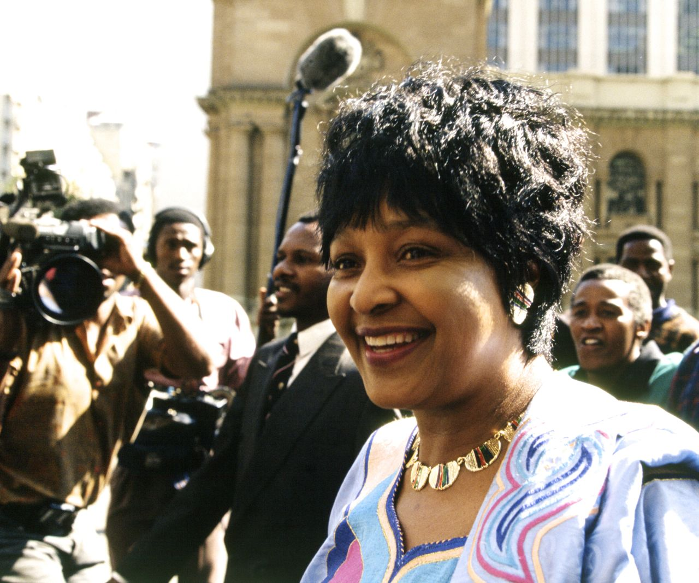
Credit: © Greg Marinovich/South Photos/Africa Media Online
While her husband Nelson Mandela was jailed for 27 years, Winnie lived a tumultuous life far from the safety of exile abroad. She came to symbolize the oppression of her people, and during the long years in which the African National Congress (ANC) languished in exile and incarceration her fearlessness incited them to get organized. She was the barometer for the political temperature of the country and willingly brushed patriarchal and conservative conventions aside.
During the long struggle, Winnie remained her husband’s eyes and ears on the ground, his closest advisor. But her insistent and often militant stance did not sit well with the powers that be. She became the target of a government-sponsored smear campaign, her inner circle was infiltrated with spies and she was eventually betrayed by many of those she most trusted.
Once change became inevitable, and as secret negotiations began for the release of her husband, the ‘Winnie Problem’ began to receive a new kind of attention. “They tried to pitch my parents like the Saint and the Sinner,” their daughter Zindzi recounts, “and you’re thinking: ‘What even gives you the right?’”
The country’s leaders soon faced stark choices in the difficult transition to democracy and the stakes were high. The final act of the film traces a roller-coaster ride of fascinating political intrigue as the Mandela marriage is torn apart with significant consequences for Winnie and the future of the country as a whole.
“I made three films in South Africa and interviewed Nelson Mandela for two of them, but I was always intrigued by Winnie, and felt a little unsettled by the adulation that was poured on her husband, while she was cast as the fallen woman,” says filmmaker Lamche. “Her reputation among people I encountered in Europe and the States was unshakably negative and yet in South Africa, Winnie was loved and respected. I became more and more fascinated by the wide chasm between the two images. Something was amiss. A story needed telling.”

“We study the contributions of leaders like Nelson Mandela, Desmond Tutu, and Oliver Tambo who fought to end apartheid in South Africa,” said Lois Vossen, Independent Lens Executive Producer. “Yet the decades-long impact of Winnie Mandela is often overlooked. Highly provocative and unapologetic, her personal story, like that of many leaders, is flawed. Although deeply controversial throughout her life, the former wife of Africa’s first Black president is seen by many in her country as the mother of the anti-apartheid movement, and Winnie is proof that women cannot be written out of history.”

Visit the Winnie page on Independent Lens, which features more information about the film. Winnie will be available for online viewing on the site beginning February 6, 2018.

About the Filmmaker

Pascale Lamche (Writer/Director) is an award-winning filmmaker who has made feature documentaries and series both as a writer/producer and writer/director for key broadcasters internationally. Her films have premiered at many international film festivals, including Edinburgh, Locarno, Dublin, the Toronto Documentary Festival, FIPA Documentary Film Festival, and have travelled the world. Her credits include Stalingrad (2014), Black Diamond (2010), Pakistan-Zindabad (2007), French Beauty (2005), Accused No1: Nelson Mandela (2004) and Sophiatown (2003). Lamche won the World Cinema Documentary Directing Award at the 2017 Sundance Film Festival for Winnie.

CREDITS

Written and Directed by Pascale Lamche
Producer Christoph Jörg
Directors of Photography Olivier Raffet
Felix Meyburgh
Editors Giles Gardner
Original Music Daniël Hamburger
Production Company Pumpernickel Films

About Independent Lens

Independent Lens is an Emmy® Award-winning weekly series airing on PBS Monday nights at 10:00 PM. The acclaimed series, with Lois Vossen as executive producer, features documentaries united by the creative freedom, artistic achievement, and unflinching visions of independent filmmakers. Presented by ITVS, the series is funded by the Corporation for Public Broadcasting, a private corporation funded by the American people, with additional funding from PBS, the John D. and Catherine T. MacArthur Foundation, Wyncote Foundation, and the National Endowment for the Arts. For more visit pbs.org/independentlens. Join the conversation: facebook.com/independentlens and on Twitter @IndependentLens.

###

