PBS COMMISSIONS THE IDEAS ROOM TO GO INSIDE THE COURT OF HENRY VIII

-The Ideas Room to Produce Documentary to Accompany “Wolf Hall” on MASTERPIECE
on PBS-

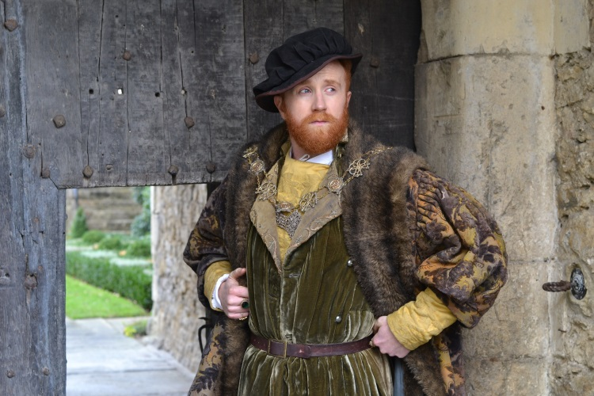
Henry VIII, Courtesy of Katie Oriel/Ideas Room TV
ARLINGTON, VA; March 25, 2015 - PBS has commissioned The Ideas Room to produce INSIDE THE COURT OF HENRY VIII, a one-hour documentary about the reign of the Tudor king. The program, scheduled for broadcast on Tuesday, April 7, 2015, at 8:00 p.m. ET, gives factual context to the historical drama “Wolf Hall” on MASTERPIECE, airing Sundays beginning April 5 at 10:00 p.m. ET on PBS.

INSIDE THE COURT OF HENRY VIII, directed by Peter Chinn, gives insight into the intrigue and politics that underlay the royal court, examining the backdrop to one of the most famous and tyrannical reigns in British history, as well as the ongoing legacy of King Henry VIII.

Filmed on location at palaces and other places of historical significance—from Anne Boleyn’s childhood home at Hever Castle to the great buildings of Hampton Court, Lambeth Palace and The Tower of London—the documentary provides five historians’ expert commentary on the reality of life under King Henry VIII interspersed with sumptuous dramatic reconstructions of key events that shaped the period. Opening at the end of Henry’s reign, with the irascible 400-pound king on his deathbed, the program tells the story of his life, beginning as a young, carefree prince, and explores his four-decade rule through some of the most turbulent periods in British history.

“INSIDE THE COURT OF KING HENRY VIII delivers a fresh perspective on one of the most exciting and dangerous periods in history,” said Jeremy Dear, founder of The Ideas Room. “Henry would brook no opposition to his will. This is a man who fundamentally changed the way the English worshipped, along with their politics and their economy, all to satisfy his own ends. Our film shows what it was really like to participate in his royal court during that time, and puts Henry’s legacy into its historical context. It’s a fantastic opportunity to provide a factual companion to “Wolf Hall” on MASTERPIECE, one of the most acclaimed adaptations of recent times.”

“This documentary is a terrific companion to highlight “Wolf Hall” on MASTERPIECE, illustrating exactly how high the stakes were in King Henry’s court, from the politics, the intrigue and day-to-day life, where anyone’s future rested on one man’s whim,” said Bill Margol, Sr. Director, Programming & Development for PBS. “Beautifully filmed in palaces and locations from the time, the documentary shows that reality is equally as engaging as fiction.”

Expert commentary provided by: Dr. Tracy Borman, Chief Curator of Historic Royal Palaces; Dr. Robert Hutchinson, Author and Historian; Susan Ronald, Author and Historian; Chris Skidmore MP, Author and Historian; Professor Diarmaid MacCulloch, University of Oxford

About the Ideas Room
Set up by Jeremy Dear in 2014, The Ideas Room develops and produces content across the factual spectrum, from popular science to lifestyle and factual entertainment.

About PBS
PBS, with over 350 member stations, offers all Americans the opportunity to explore new ideas and new worlds through television and online content. Each month, PBS reaches more than 103 million people through television and over 33 million people online, inviting them to experience the worlds of science, history, nature and public affairs; to hear diverse viewpoints; and to take front row seats to world-class drama and performances. PBS’ broad array of programs has been consistently honored by the industry’s most coveted award competitions. Teachers of children from pre-K through 12th grade turn to PBS for digital content and services that help bring classroom lessons to life. PBS’ premier children’s TV programming and its website, pbskids.org, are parents’ and teachers’ most trusted partners in inspiring and nurturing curiosity and love of learning in children. More information about PBS is available at www.pbs.org, one of the leading dot-org websites on the Internet, or by following PBS on Twitter, Facebook or through our apps for mobile devices. Specific program information and updates for press are available at pbs.org/pressroom or by following PBS Pressroom on Twitter.

– PBS –

For additional information, photos, interviews and more, contact PBS:

Michaé Godwin, PBS, mmgodwin@pbs.org; 703-739-8483

For images and additional up-to-date information on this and other PBS programs, visit PBS PressRoom at pbs.org/pressroom.

