ICON: MUSIC THROUGH THE LENS Explores the Thrilling World of Music Photography on PBS
Fridays, July 16-August 13, 2021

The World’s Most Iconic Photographers, Musicians and Industry Experts Give Viewers a Backstage Pass into the Electrifying World of Music Photography in New Six-Part Series

ARLINGTON, VA (May 26, 2021) – PBS, in partnership with FilmRise and Universal Music Group’s Mercury Studios, announced today the premiere of ICON: MUSIC THROUGH THE LENS, a new six-part series that exposes the eye-opening, thrilling world of live music photography.
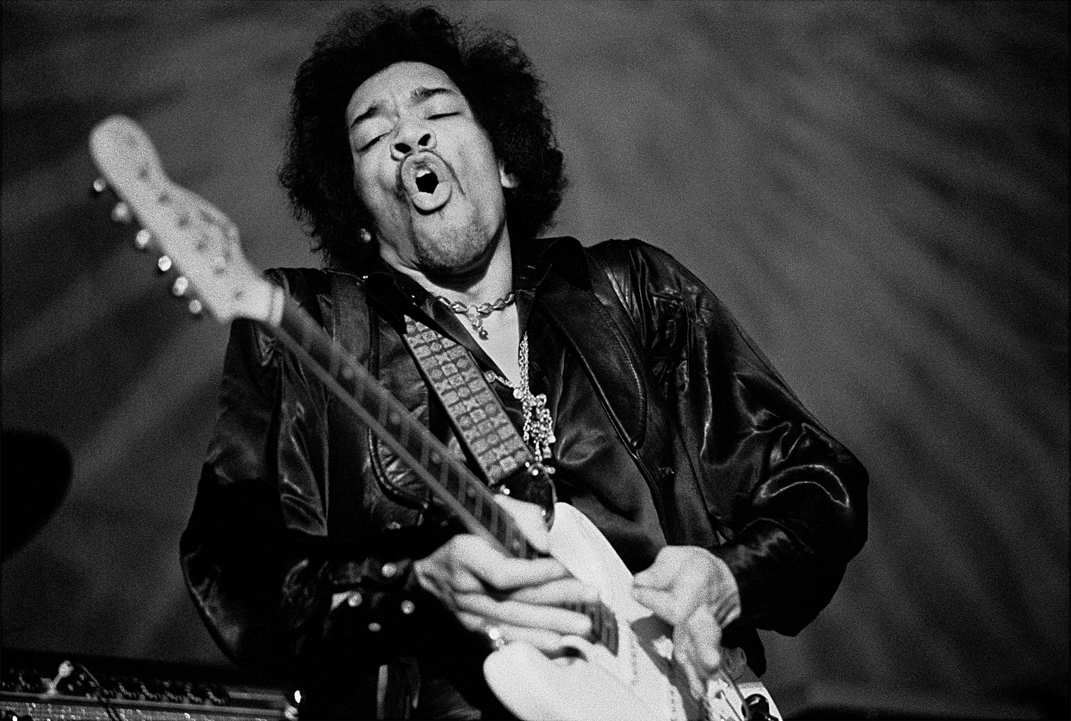
Jimi Hendrix.
Credit: Courtesy of Baron Wolman

ICON follows the fascinating lives and often wild experiences of the artists who documented popular music in images, from the earliest darkrooms to the fast-evolving digital landscapes of the present day. The series premieres Fridays, July 16-August 6, 2021, 9:00-10:00 p.m. ET & August 13, 2021, 9:00-11:00 p.m. ET (check local listings) on PBS, PBS.org and the PBS Video app.

Featuring irreverent interviews with some of the most famous music photographers, musicians, gallerists, music journalists and social commentators, ICON: MUSIC THROUGH THE LENS is an eye-opening thrill ride that captures what it was like on both sides of the camera when the most recognizable images in history were taken. Via studio portraits, record sleeves, coffee table books, along with magazine photo shoots, fine art, and images taken at live shows and exhibitions, viewers will learn about the origins of these enduring, iconic images and the future of music photography.

“As the nation’s largest stage, PBS continues to bring captivating and energizing arts and performance programming to American homes,” said PBS Chief Programming Executive and General Manager, General Audience Programming Sylvia Bugg. “Each of the six riveting episodes of ICON: MUSIC THROUGH THE LENS unfolds like an exclusive all-access pass to some of the most well-known concerts and photoshoots in music history, inviting our viewers behind the curtain and backstage.”

“ICON is a dream come true for me," said Gered Mankowitz, executive producer and renowned music photographer. “For over 10 years, director Dick Carruthers, fellow executive producer Andy Saunders and I have been trying to get this series made, and now to have it aired on PBS in the USA is the icing on the cake. I have been committed to music photography since 1963 and have been fighting to get the genre taken seriously as an art form in its own right for most of that time. ICON does the job, and I hope you will enjoy watching it as much as we loved making it.”

Photographers interviewed include industry legends Jill Furmanovsky, Mick Rock, Danny Clinch, Michael Zagaris, Bruce Talamon, Kevin Westenberg, Terry O’Neill, Kevin Cummins, Bob Gruen, Rachael Wright, Deborah Feingold, Rankin, Laura Levine, Baron Wolman, Neal Preston, Janette Beckman, Roger Sargent, Pooneh Ghana, Christie Goodwin, Albert Watson and Lynn Goldsmith.

Sharing eye-opening insights from a musician’s viewpoint are Josh Homme (Queens of The Stone Age), Ziggy Marley, Lars Ulrich, (Metallica), Brett Anderson (Suede), Alice Cooper, Craig David, Nick Mason (Pink Floyd), Zara Larsson, Stefflon Don, Sharleen Spiteri (Texas), Nicky Wire (Manic Street Preachers), Matt Helders (Arctic Monkeys), Julian Lennon and Dizzee Rascal.

Full episode descriptions are below:

Episode One – “On Camera” (Friday, July 16, 9:00-10:00 p.m. ET)
What makes an image iconic? Episode One explores how photographic images of Snoop Dogg, Bob Dylan and Madonna influence perceptions and how they communicate, through themes of interaction, technical skill, occasional luck and cultural impact. The episode goes back to Robert Johnson to find the genesis of music photographs that demonstrate the incredible power of a frozen moment in time. Other highlights include Kevin Cummins on Joy Division, Gered Mankowitz on Jimi Hendrix and Rachael Wright on Billie Eilish trying not to be beautiful.

Episode Two – “On the Road” (Friday, July 23, 9:00-10:00 p.m. ET)
On stage, backstage, on the tour bus—from the earliest days of live performance to the modern day, visually striking live music photographs have captured moments of pure magic and created era-defining imagery. Episode Two features touring stories from early trailblazers who went on the road with artists such as Led Zeppelin, David Bowie, The Rolling Stones and The Who, mixed with tales from the punk era of CGBGs, the Clash and the Sex Pistols. The episode also explores photographers’ relationships with Oasis, Metallica, U2, Ed Sheeran and Courtney Barnett, plus special sections on music photography legend Jim Marshall and the origins of the “Three Songs, No Flash” rule.

Episode Three – “On the Record” (Friday, July 30, 9:00-10:00 p.m. ET)
The photography of record sleeves from jazz and early rock ’n’ roll is analyzed and explored, from the Beatles and Pink Floyd to the highly stylized and conceptual imagery on albums by Blur and Dizzee Rascal. Themes of nostalgia, resonance and association run through the superb stories of classic album covers by the Jam, Lou Reed, Thin Lizzy, Bruce Springsteen, Iggy Pop, Joy Division and Crosby Stills and Nash. Highlights include Lynn Goldsmith on Patti Smith’s Horses, Jonathan Mannion on Jay-Z and DMX, and Elliott Landy on Bob Dylan’s Nashville Skyline.

Episode Four – “On the Cover” (Friday, August 6, 9:00-10:00 p.m. ET)
Music magazines played a pivotal role in elevating music photography to iconic status, providing a visual context for some of the world’s greatest bands and their music. This episode explores the legacy of the early covers of Rolling Stone, Creem, NME, Mojo and Q. Journalists, musicians and publicists discuss the enduring appeal and importance of the printed page, with music photographers who shot many of the most iconic front covers telling some touching, scandalous and never-heard-before stories about these images. Highlights include Chalkie Davies’ story of how Elton John hoped to use an NME magazine cover to come out, a young Michael Jackson, Mick Jagger with a leopard and the Stone Roses with a lot of paint. The episode also reveals how magazines covered the deaths of David Bowie and Kurt Cobain.

Episode Five – “On the Wall” (Friday, August 13, 9:00-10:00 p.m. ET)
The transition of music photography from being considered disposable to a highly collectable and valuable art form is examined by gallerists, publishers, art experts and featured photographers whose body of work now hangs on the walls of the world’s most revered institutions. Tracing the journey from the early days of low-paid assignments to the first gallery exhibitions of music photography and expensive coffee table books, ultimately arriving at individual prints now selling for six and even seven figure sums, this episode offers insight into this relatively new industry, exploring the relationship between art and commerce. Highlights include the section on Abbey Road - the “Holy Grail” of music photographs - Bruce Talamon on Miles Davis and how he got his Taschen book deal, Chris Floyd on waiting all day for the ‘real’ Paul McCartney, Jill Furmanovsky on her profile of a shy Charlie Watts and Bob Gruen on getting a surprise call from the UK’s National Portrait Gallery.

Episode Six – “On the Net” (Friday, August 13 from 10:00-11:00 p.m. ET)
Where does music photography sit in the contemporary popular culture landscape? The seismic switch from analogue to digital is discussed alongside the rise and influence of social media. Episode six ends the series in seeking to determine, through the next generation of music photographers, whether music photography still has a role to play—does it still carry the same importance, and who are the new standard bearers of the profession?

ICON: MUSIC THROUGH THE LENS was produced and directed by Dick Carruthers, whose celebrated career includes award-winning work with many of the artists featured in the series such as Oasis, Led Zeppelin and The Rolling Stones, along with Gered Mankowitz and Andy Saunders serving as executive producers . Executive in charge for PBS is Zara Frankel.

ICON: MUSIC THROUGH THE LENS features music by: Robert Johnson, Seasick Steve, Jimi Hendrix, The White Stripes, The Rolling Stones , Bob Dylan, Madonna, Queen, Iggy Pop, Elton John, Bruce Springsteen, David Bowie, The Who, Metallica, Alice Cooper, Oasis, Pink Floyd, Iggy Pop & Josh Homme, Dizzee Rascal, The Libertines, Happy Mondays, Leonard Cohen, ODB, Salt N Pepa, Slick Rick, Paul McCartney, Julian Lennon, Manic Street Preachers, Grandmaster Flash and the Furious Five, The Strokes, The Band, Janis Joplin, Courtney Barnett, Plain White T’s, Zara Larsson, Mahalia and Stefflon Don.

About PBS
PBS, with more than 330 member stations, offers all Americans the opportunity to explore new ideas and new worlds through television and digital content. Each month, PBS reaches over 120 million people through television and 26 million people online, inviting them to experience the worlds of science, history, nature and public affairs; to hear diverse viewpoints; and to take front row seats to world-class drama and performances. PBS’ broad array of programs has been consistently honored by the industry’s most coveted award competitions. Teachers of children from pre-K through 12th grade turn to PBS for digital content and services that help bring classroom lessons to life. Decades of research confirms that PBS’ premier children’s media service, PBS KIDS, helps children build critical literacy, math and social-emotional skills, enabling them to find success in school and life. Delivered through member stations, PBS KIDS offers high-quality educational content on TV – including a 24/7 channel, online at pbskids.org, via an array of mobile apps and in communities across America. More information about PBS is available at www.pbs.org, one of the leading dot-org websites on the internet, or by following PBS on Twitter, Facebook or through our apps for mobile and connected devices. Specific program information and updates for press are available at pbs.org/pressroom or by following PBS Communications on Twitter.

About FilmRise
FilmRise is an industry-leading film and television studio as well as the largest privately owned AVOD streaming network, based in Brooklyn, NY. Founded in 2012 by veteran producers and financiers Danny Fisher, Jack Fisher and Alan Klingenstein, FilmRise is a recognized market leader and innovator, considered the largest independent provider of ad-supported content. At the forefront of analytics-led curation and distribution, FilmRise offers over 40,000 film and television titles across multiple worldwide streaming platforms. FilmRise's impressive library includes such iconic titles as Gordon Ramsay’s HELL'S KITCHEN, Carsey-Werner’s 3RD ROCK FROM THE SUN, the Robert Stack-hosted true crime series UNSOLVED MYSTERIES, the high-tech documentary crime series FORENSIC FILES, classic television shows like THE RIFLEMAN, the popular family comedy-drama series HEARTLAND as well as award-winning feature films and documentaries including 2020 Tribeca Film Festival Best Documentary winner REWIND, true crime thriller MY FRIEND DAHMER starring Ross Lynch and Anne Heche, two-time 2020 Spirit Award-nominated and top film critics' favorite DRIVEWAYS starring Brian Dennehy and the Sundance Grand Jury Prize-winning feature film THE MISEDUCATION OF CAMERON POST starring Chloë Grace Moretz. For more information, go to: filmrise.com

About Mercury Studios
Mercury Studios is a multi-faceted content studio established to develop, produce, globally distribute and invest in innovative, music-rooted storytelling across a range of media including film, television, podcasting, publishing and live-streamed performance. Taking its name from the iconic Mercury Records label, Mercury Studios is powered by Universal Music Group and creates an open space for experimentation to unleash and amplify both emerging and established artists. With offices in London and Los Angeles, Mercury Studios harnesses its established relationships with best-in-class talent from music and film, seamlessly bridging the two worlds to create a completely distinctive community of trailblazers driven by original IP, innovation and collaboration.

– PBS –
CONTACTS:

Stephanie Kennard, PBS,; skkennard@pbs.org

Meredith Wohl, PBS,; mawohl@pbs.org

DKC,; PBSSeries@dkcnews.com

For images and additional up-to-date information on this and other PBS programs, visit PBS PressRoom at pbs.org/pressroom

