HUMAN FOOTPRINT
PANELIST BIOS

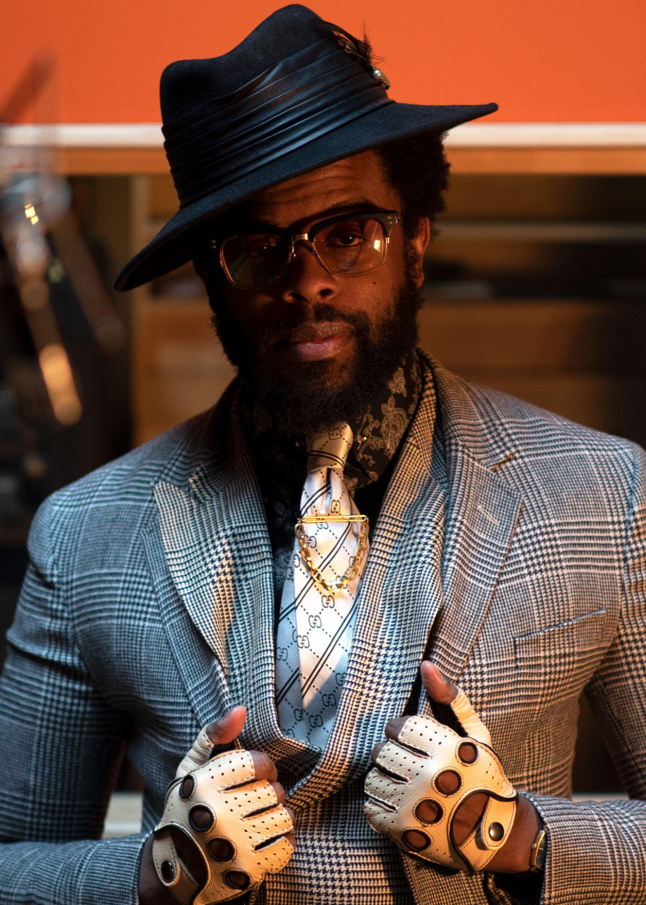
Adrian Younge is a self-taught multi-instrumentalist, composer and orchestrator who has produced for entertainment greats such as Snoop Dogg, Kendrick Lamar and Wu-Tang Clan.

In 2007, Younge relinquished his position as a professor of law to find himself at the center of the Black Dynamite phenomenon. He served as the film’s editor and composer. Hailed as a modern blaxploitation masterpiece, the soundtrack was listed in the top 10 best soundtracks of the year by the LA Times.

In 2011, Younge created the album Something About April, showcasing a dark mix of psychedelic soul and cinematic instrumentals. In 2013, the project was sampled twice by Timbaland for Jay- Z’s Magna Carta... Holy Grail, solidifying Younge as a new sound in hip hop. Younge’s work has also been sampled by various artists including No I.D., DJ Premier, Schoolboy Q and more.

Younge owns and operates Linear Labs, a recording studio and label. Linear Labs reflects his dedication to the art of analog recording, utilizing analog tape and live instrumentation exclusively. Under the label, he’s produced projects for artists such as Ghostface Killah, Souls of Mischief and the Delfonics.
In 2017, Younge and Ali Shaheed Muhammad (A Tribe Called Quest) formed the band the Midnight Hour. In addition to musical releases and touring, they’ve teamed to score a myriad of television and film projects: Marvel’s “Luke Cage” (Netflix), “Raising Kanan” (Starz), “The Equalizer” (CBS), “Reasonable Doubt” (Hulu), Run This Town (2019), Washington Black (2023), Boogie (2021) and Bitchin’: The Sound and Fury of Rick James (2021). Younge has also scored Black Dynamite (2009), “Black Dynamite” animated series (2012), California King (2023), The Big Payback (2023), “Queens” (ABC), “All Rise” (OWN) and HUMAN FOOTPRINT (PBS).

In 2019, Younge, Muhammad, Andrew Lojero and Adam Block created Jazz Is Dead (JID), a multimedia company specializing in the production of live concerts, studio albums, television and film. JID concerts have earned an ever-growing fanbase through national and international tours. Under the label, Younge and Muhammad have produced albums with their musical heroes including luminaries such as Roy Ayers, Lonnie Liston Smith, Gary Bartz, Jean Carne, Marcos Valle and Tony Allen.

In February 2021, Younge released the seminal album The American Negro, his most important work to date. This project, in tandem with his Amazon original podcast Invisible Blackness and short film “TAN,” provides an unapologetic critique on the evolution of racism in America. The podcast features conversations with guests such as Chuck D, Roy Choi, Dr. Melina Abdullah, Wayne Brady and Mahershala Ali. For Younge, the message is more important than the music.

Josh Tetrick is CEO & co-founder of Eat Just, Inc., a food technology company with a mission to build a healthier, safer and more sustainable food system in our lifetimes. The company's expertise, from functionalizing plant proteins to culturing animal cells, is powered by a world-class team of scientists and chefs spanning more than a dozen research disciplines. Eat Just created one of America’s fastest-growing egg brands, which is made entirely of plants, and the world’s first-to-market meat made from animal cells instead of slaughtered livestock. Prior to founding Eat Just, Tetrick led a United Nations business initiative in Kenya and worked for both former President Clinton and Liberian President Ellen Johnson Sirleaf. As a Fulbright Scholar, Tetrick taught schoolchildren in Nigeria and South Africa, and is a graduate of Cornell University and the University of Michigan Law School. Tetrick has been named one of Fast Company’s “Most Creative People in Business,” Inc.’s “35 Under 35” and Fortune’s “40 Under 40.” Eat Just has been recognized as one of Fast Company’s “Most Innovative Companies,” Entrepreneur’s “100 Brilliant Companies,” CNBC’s “Disruptor 50” and a World Economic Forum Technology Pioneer.

Nate Dappen is a director, senior producer, and an owner at Day's Edge Productions. Before going into documentary film, he earned his Ph.D in Biology at the University of Miami, where he studied evolution and genetics. Since 2012, he’s been making science, natural history and adventure documentaries full time. Nate is a Fellow of the Explorers Club and an Affiliate of the International League of Conservation Photographers. When he's not making films, or with his wife and three daughters in Ocean Beach, San Diego, you can find him surfing, doing Brazilian jiu-jitsu and enjoying IPAs.

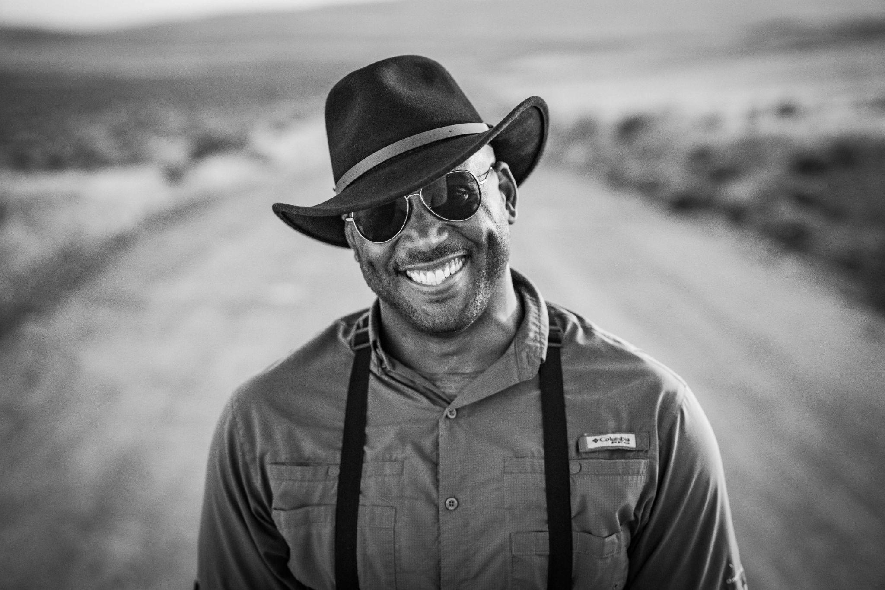
Shane Campbell-Staton is an evolutionary biologist and assistant professor at Princeton University. His research focuses on how human history and activity drive evolutionary change in wild species across the planet. He studies a wide array of animals that are rapidly adjusting to life alongside humans, from lizards adapting to survive in cities to the evolution tuskless African elephants in response to poaching. In 2022, Shane was named a Pew Biomedical Scholar for his collaborative research on the evolution of cancer resilience in gray wolves living within the Chernobyl Exclusion Zone. His research has been featured in several media outlets including the New York Times, The Atlantic, Scientific American, Science Friday With Ira Flatow, Sports Illustrated and “The Daily Show With Trevor Noah.” Beyond research and academics, Shane is passionate about sharing his love for science with a broad audience. He has been previously featured in nature and science content for various online media outlets, the Discovery Channel and the Smithsonian Channel. He is the creator and host of The Biology of Superheroes Podcast, which explores cutting-edge scientific research using stories and characters from comic books and science fiction.

