American Experience The Polio Crusade
To Have Encore Broadcast Tuesday, June 15, 2021

A Deadly Virus Is Defeated by a Tireless Crusader, a Scientific Researcher and Dimes from Millions of Americans
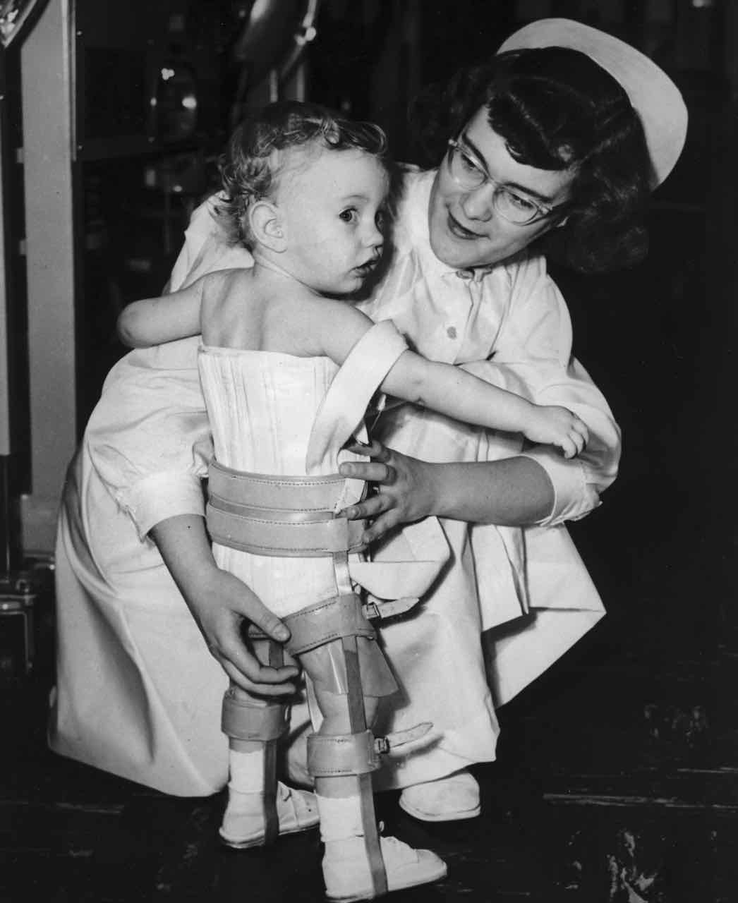
Credit: March of Dimes

(Boston, MA) – The Polio Crusade, produced, directed and written by Sarah Colt, pays tribute to an earlier time when fears of a virus gripped the nation, and Americans banded together to conquer a terrible disease. The film interweaves the personal accounts of polio survivors with the story of an ardent crusader who tirelessly fought on their behalf while scientists raced to find a medical breakthrough. Based in part on David Oshinsky’s Pulitzer Prize-winning book Polio: An American Story, the film features an interview with Julius Youngner, the only surviving scientist from the core research team that developed the Salk vaccine. The Polio Crusade will have an encore broadcast on American Experience Tuesday, June 15, 2021, 9:00-10:00 p.m. ET (check local listings) on PBS, PBS.org and the PBS Video App.

In the summer of 1950 fear swept through the town of Wytheville, Virginia. Movie theaters shut down, baseball games were cancelled and panicky parents kept their children indoors. Outsiders sped through town with their windows rolled up and bandanas covered their faces. The ones who couldn’t escape the disease were left paralyzed, and some died in the wake of the devastating and contagious virus. Polio had struck in Wytheville. The town was in the midst of a full-blown epidemic. That year alone, more than 33,000 Americans fell victim — half of them under the age of ten.

Anne Crockett-Stark, just seven years old when her brother fell ill during Wytheville’s polio epidemic, recalls: “Daddy and Mama took everything Sonny owned, all of his clothes, his bed, his chest of drawers, and he had a fabulous comic book collection. They took everything out to the middle of the garden, and they made a pile and burned everything he owned. They were told to do that, so we would not get it.”

Decades before, polio victims found an unlikely champion in New York lawyer Basil O’Connor, who, in 1928, inherited the leadership of a polio rehabilitation center from his law partner, future president Franklin Delano Roosevelt. As the nation reeled from the economic trauma of the Great Depression, O’Connor faced a pressing challenge: funding. Rather than relying on wealthy philanthropists, O’Connor asked the public to contribute whatever they could. Within days, envelopes stuffed with change flooded the White House mailroom. “The March of Dimes” was born.

O’Connor invested in scientific research to create a vaccine that would end the disease and was impressed with one young researcher, whose sense of urgency matched his own: Dr. Jonas Salk, the director of the Virus Research program at the University of Pittsburgh.

Salk, who had been part of a government effort to develop an influenza vaccine during World War II, believed he could apply the same technique — using killed virus — to polio. But established researchers scoffed at Salk’s theory and dismissed his methods. A bitter feud arose between Salk and his leading rival Albert Sabin, an established polio researcher at the University of Cincinnati who was working on a live virus vaccine.

The two men were unrelenting in their quest, but it was Salk who would introduce his formula first. On April 26, 1954, the Salk vaccine field trials began, the largest public health experiment in American history. No one was certain it was safe or whether it could provide effective protection against the crippling disease. By June 1954, nearly two million school children in 44 states had taken part.

On April 12, 1955, almost a year after the field trials ended, the Salk vaccine was ruled “safe, effective, and potent.” Within just a few years of being licensed, the Salk vaccine decreased the number of polio cases in the United States by 50 percent. By the early 1960s, the number of Americans contracting polio fell to a few thousand annually.

“This vaccine vindicated 20 years of giving dimes, 20 years of volunteering,” says David Oshinsky in the film. “It was a victory for millions of faceless people who had done what they could to end the scourge of polio.”

About the Filmmakers

Producer, Director, Writer  Based in part on the book | SARAH COLT  POLIO: AN AMERICAN STORY BY  DAVID OSHINSKY
Associate Producer | STEPHANIE MILLS
Editor | RANDALL MACLOWRY
Music  Senior Consultant  Narrator | JOHN KUSIAK  DAVID OSHINSKY  LINDA HUNT

American Experience is a production of WGBH Boston
Executive Producer | CAMEO GEORGE

About American Experience
For more than 30 years, American Experience has been television’s most-watched history series, bringing to life the incredible characters and epic stories that have shaped America’s past and present. American Experience documentaries have been honored with every major broadcast award, including 30 Emmy Awards, five duPont-Columbia Awards and 19 George Foster Peabody Awards. PBS’s signature history series also creates original digital content that innovates new forms of storytelling to connect our collective past with the present. Cameo George is the series executive producer. American Experience is produced for PBS by GBH Boston. Visit pbs.org/americanexperience and follow us on Facebook Twitter, Instagram and YouTube to learn more.

Major funding for American Experience provided by Liberty Mutual Insurance, Consumer Cellular and by the Alfred P. Sloan Foundation. Additional funding provided by the Robert David Lion Gardiner Foundation, The Documentary Investment Group, the Corporation for Public Broadcasting and public television viewers.

* * *
Press Contacts:
CaraMar Publicity
Mary Lugo 770-623-8190 lugo@negia.net
Cara White 843-881-1480 cara.white@mac.com
Abbe Harris 908-244-5516 abbe.harris@caramar.net

For further information and photos visit http://www.pbs.org/pressroom

Original Broadcast: 2/2/09

