American Experience The Murder of Emmett Till
To Have Encore Broadcast on Tuesday, August 23, 2022 on PBS and Streaming on PBS.org

Acclaimed Documentary Film Directed by Stanley Nelson Helped Prompt the U.S. Justice Department of Justice to Reopen the Case

In August 1955, Emmett Till, a 14-year-old Black teenager from Chicago, was accused of whistling at a white woman in a grocery store in Money, Mississippi. Three days after the incident, he was kidnapped, beaten and shot by two white men. His mangled remains were found in the Tallahatchie River several days later. The brutal murder horrified the nation and the world, and Till's death became a spark that helped mobilize the Civil Rights Movement. The Murder of Emmett Till, Stanley Nelson’s acclaimed documentary, features interviews with Till’s mother, witnesses, friends and others who reveal how the inadvertent violation of a code of the South cost a Black teenager his life. Originally broadcast in 2003, the documentary uncovered new eyewitnesses to the crime and helped prompt the U.S. Department of Justice to reopen the case, which continues to make headlines today. The Murder of Emmett Till will have an encore broadcast on American Experience on Tuesday, August 23, 9:00-10:00 p.m. ET (check local listings) on PBS, PBS.org and the PBS Video app.
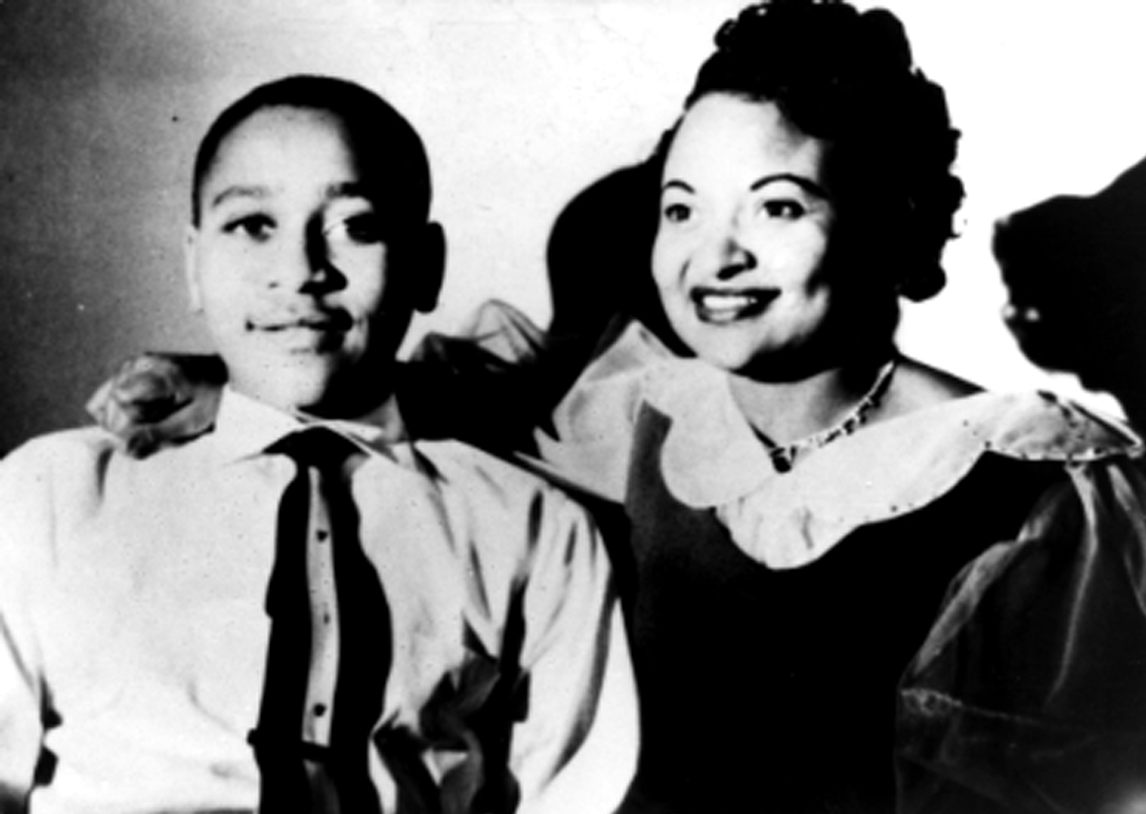
Emmett Till with his mother, Mamie Till, early 1950s.
Credit: Courtesy of Mamie Till Mobley

After Till’s body was returned to Chicago, his mother made a decision that would bring national attention to her son’s slaying. In The Murder of Emmett Till, Mamie Till Mobley (who died in January 2003, just weeks before the documentary's original broadcast) relates how she instructed the undertaker not to “touch up” the body, and to leave the casket open: “Let the people see what I've seen. Everybody needs to know what happened to Emmett Till.”

Mamie's courageous act would make Emmett Till’s death a touchstone for a generation. At a church on the South Side of Chicago, her 14-year-old son’s remains would be on display for the thousands who stood in line in order to serve as witnesses and offer condolences. Graphic photographs of Till’s mutilated body were also published in Jet magazine, further shocking and outraging the nation.

Till’s assailants—two white men who later confessed to the crime in a published article—were arrested and tried for murder, but quickly acquitted by an all-white, all-male jury. The failure of the courts or government to respond to outcries for justice was an emotional spark for the Civil Rights Movement. One hundred days after the discovery of Till’s body, Rosa Parks refused to give up her bus seat to a white man, and the Montgomery bus boycott was born.

“The murder of Emmett Till is etched in the collective consciousness of generations of the Black community,” said Nelson. "His legacy speaks to the power of people to make change, of mass movements. Emmett Till’s was a story that cried out to be told.”

American Experience The Murder of Emmett Till will stream simultaneously with broadcast on all station-branded PBS platforms, including PBS.org and the PBS Video app, available on iOS, Android, Roku, Apple TV, Amazon Fire TV, Android TV, Samsung Smart TV, Chromecast and VIZIO. All titles will also be available for streaming with closed captioning in English and Spanish.

American Experience The Murder of Emmett Till

A Firelight Media Production for American Experience

Produced and Directed by | Stanley Nelson
Written by | Marcia A. Smith
Narrated by | Andre Braugher
Edited by | Lewis Erskine
Coordinating Producer | Laurens Grant
Cinematographer  Composer | Robert Shepard  Tom Phillips

American Experience is a production of GBH Boston
Executive Producer | Cameo George

About American Experience
For more than 30 years, American Experience has been television’s most-watched history series, bringing to life the incredible characters and epic stories that have shaped America’s past and present. American Experience documentaries have been honored with every major broadcast award, including 30 Emmy Awards, five duPont-Columbia Awards and 19 George Foster Peabody Awards. PBS’s signature history series also creates original digital content that innovates new forms of storytelling to connect our collective past with the present. Cameo George is the series executive producer. American Experience is produced for PBS by GBH Boston. Visit pbs.org/americanexperience and follow us on Facebook, Twitter, Instagram and YouTube to learn more.

Major funding for American Experience provided by Liberty Mutual Insurance and by the Alfred P. Sloan Foundation. Additional funding for The Murder of Emmett Till provided by the Ford Foundation. Additional funding for American Experience provided by the Robert David Lion Gardiner Foundation, The Documentary Investment Group, the Corporation for Public Broadcasting and public television viewers.

* * *
Press Contacts:
CaraMar Publicity
Mary Lugo 770-851-8190 lugo@negia.net
Cara White 843-881-1480 cara.white@mac.com

