American Experience Spotlights
Four Trailblazing Women in May with Encore Broadcasts of
Amelia Earhart, Annie Oakley, Emma Goldman and Rachel Carson

(BOSTON, MA) — American Experience will present a special salute to “Women in History” this May with encore broadcasts of four films that celebrate extraordinary women: Amelia Earhart, Annie Oakley, Emma Goldman and Rachel Carson. From the groundbreaking work of the scientist who launched the modern environmental movement to the fearless aviator who set world records, these stories explore the lives of women who became famous — or controversial — for following their own paths, regardless of the consequences, and whose achievements are still remembered today.
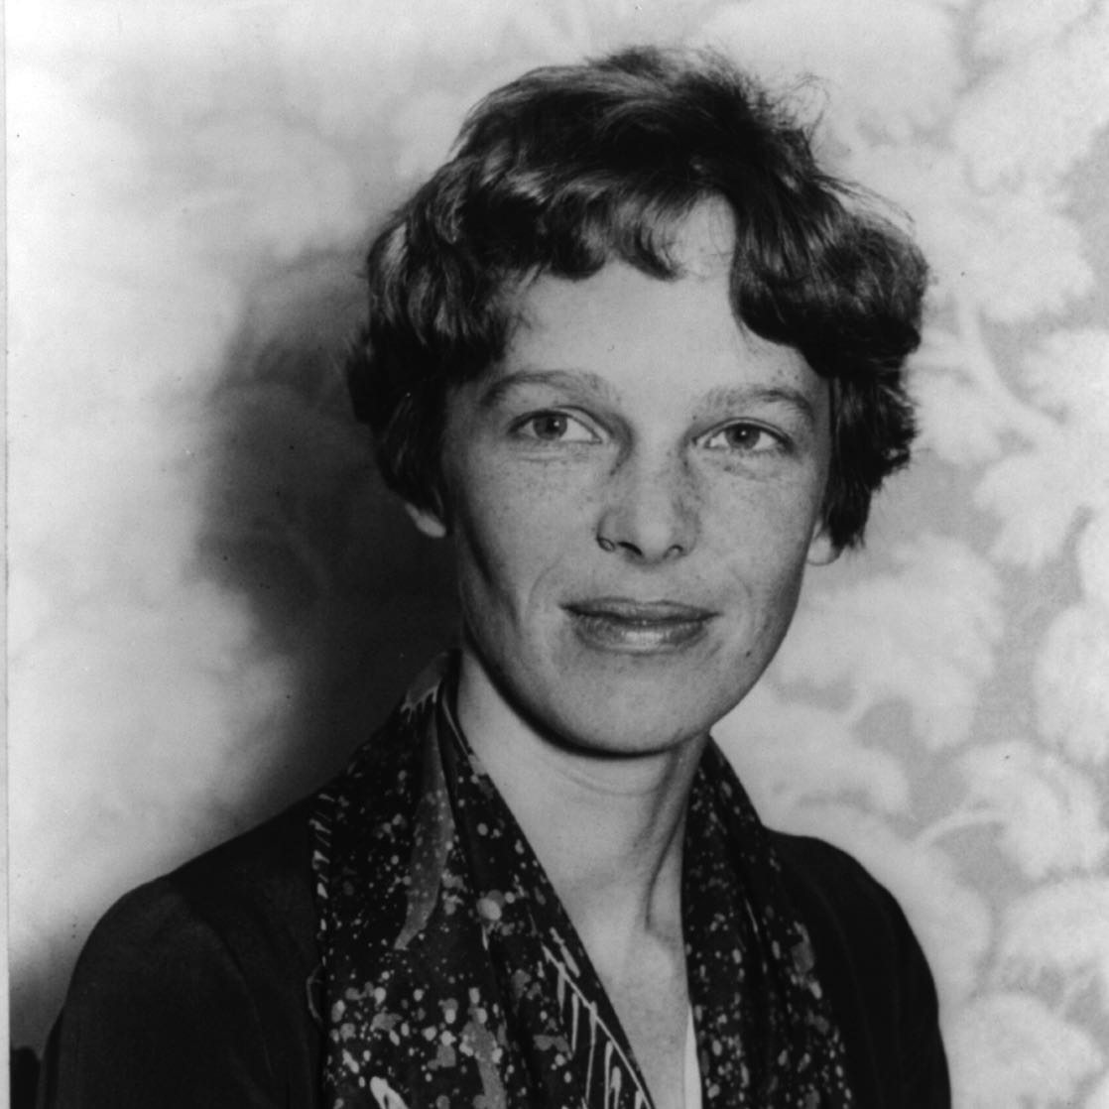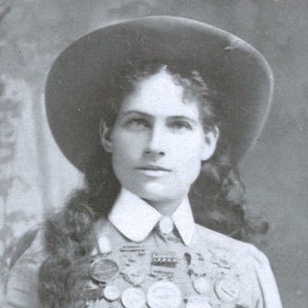
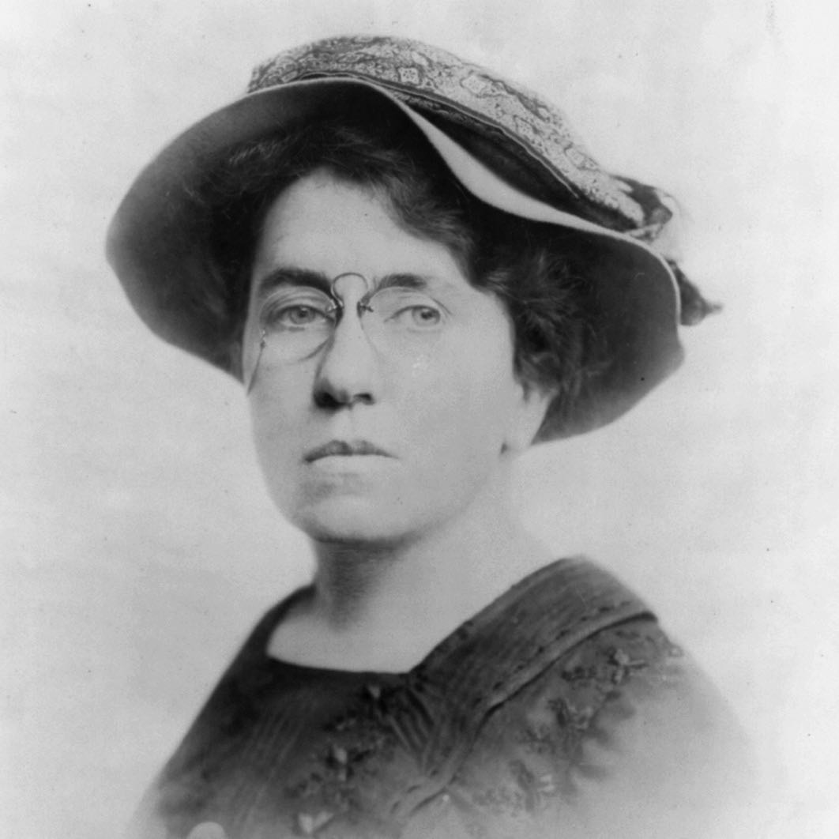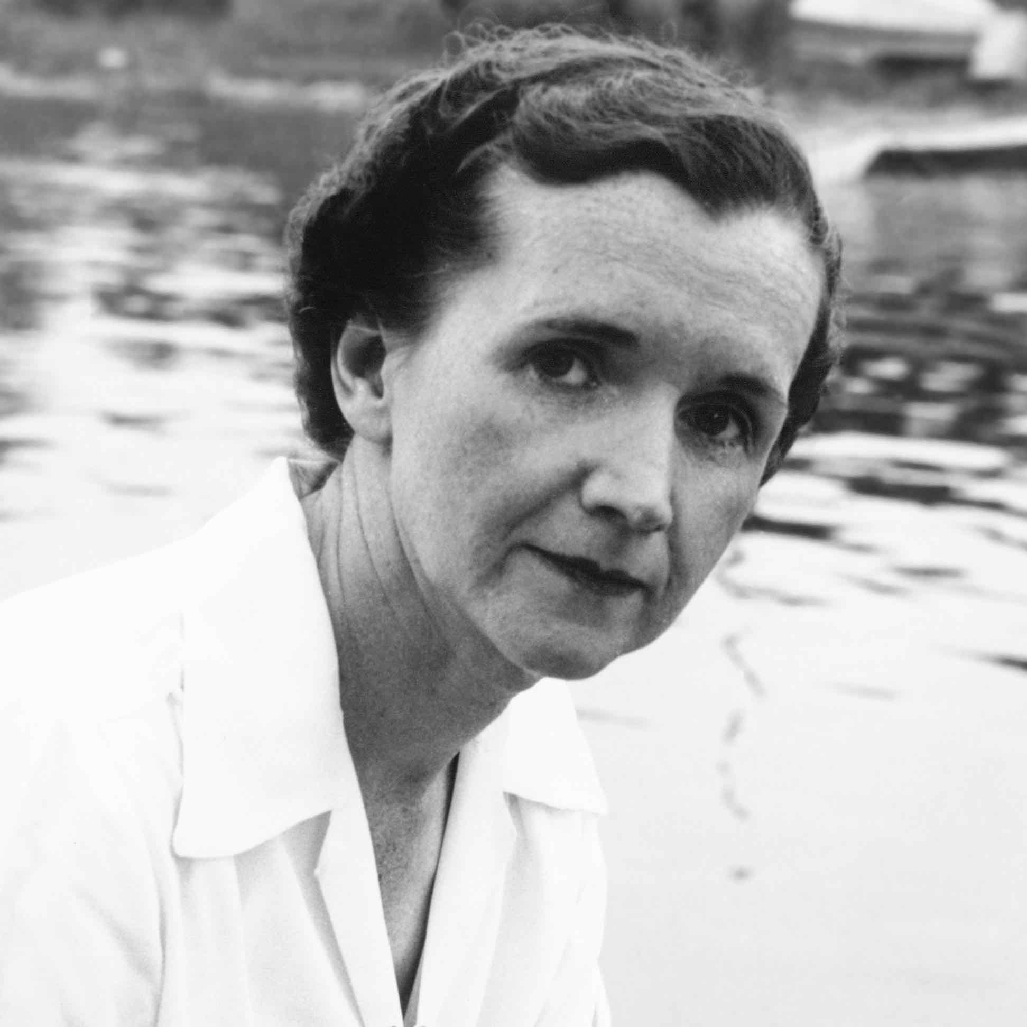
Top: Amelia Earhart, Annie Oakley.
Bottom: Emma Goldman, Rachel Carson.

Descriptions and schedule for the four encore broadcasts are below.

Amelia Earhart (Tuesday, May 7, 2019. 9-10 p.m. ET)
The first woman to fly solo across the Atlantic, Amelia Earhart was one of America’s earliest celebrities. After only a few years as a pilot she became the best-known female flier in America, not only for her daring and determination, but also for her striking looks and outspoken personality. Amelia even had an uncanny resemblance to Charles Lindbergh — the most famous man in America at the time — earning her the nickname “Lady Lindy.” Three weeks short of her 40th birthday, Earhart disappeared over the Pacific Ocean, and her story became legend.

Annie Oakley (Tuesday, May 14, 2019, 9-10 p.m. ET)
She was the toast of New York, Victorian London, Paris, and eventually the world. She was “adopted” by Indian Chief Sitting Bull, charmed the Prince of Prussia, and entertained the likes of Oscar Wilde and Queen Victoria. Annie Oakley excelled in a man’s world by doing what she loved and won fame and fortune as the little lady from Ohio who never missed a shot. Annie Oakley is the story of a five-foot, 100-pound sharp shooter who pulled herself out of the depths of poverty to become an iconic performer known the world over as a symbol of the Wild West.

Emma Goldman (Tuesday, May 21, 2019, 9-10 p.m. ET)
For nearly half a century, Russian emigrant Emma Goldman was the most controversial woman in America, taunting the mainstream with her fervent attacks on government, big business, and war. To the tabloids, she was “Red Emma, Queen of the Anarchists,” but many admired Goldman for her defense of labor rights, women’s emancipation, birth control, and as a fearless writer, and merciless publisher.

Rachel Carson (Tuesday, May 28, 2019, 8-10 p.m. ET)
When Rachel Carson’s Silent Spring was published in 1962, the book became a phenomenon. A passionate and eloquent warning about the long-term dangers of pesticides, the book unleashed an extraordinary national debate and provoked vigorous attacks from the chemical industry. But it also inspired President
John F. Kennedy to launch the first-ever investigation into the public health effects of pesticides — an investigation that eventually would result in new laws designed to protect and preserve the environment.

About American Experience
For 30 years, American Experience has been television’s most-watched history series. Hailed as “peerless” (The Wall Street Journal), “the most consistently enriching program on television” (Chicago Tribune) and “a beacon of intelligence and purpose” (Houston Chronicle), the series brings to life the incredible characters and epic stories that have shaped America’s past and present. American Experience documentaries have been honored with every major broadcast award, including 30 Emmy Awards, four duPont-Columbia Awards and 17 George Foster Peabody Awards; the series received an Academy Award® nomination for Best Documentary Feature in 2015 for Last Days in Vietnam. American Experience also creates original digital content that uses new forms of storytelling to connect our collective past with the present. Visit pbs.org/americanexperience and follow us on Facebook, Twitter, Instagram and YouTube to learn more.

Major funding for American Experience provided by Liberty Mutual Insurance, Consumer Cellular and by the Alfred P. Sloan Foundation. Additional funding provided by the Robert David Lion Gardiner Foundation, the Documentary Investment Group, the Corporation for Public Broadcasting and public television viewers. American Experience is produced for PBS by WGBH Boston.

* * *
Press Contacts
CaraMar Publicity
Mary Lugo 770-623-8190 lugo@negia.net
Cara White 843-881-1480 cara.white@mac.com
Abbe Harris 908-244-5516 abbe.harris@caramar.net

For further information and photos visit http://www.pbs.org/pressroom

Photo Credits:
Amelia Earhart, Annie Oakley and Emma Goldman: Courtesy of the Library of Congress.
Rachel Carson: The Linda Lear Center for Special Collections and Archives.

