ART HAPPENS HERE WITH JOHN LITHGOW
Premieres Friday, April 26, 2024 on PBS and Streaming on PBS.org and the PBS App

Join the Emmy and Tony Award-Winning Actor as He Goes Back to School to Celebrate the Transformative Power of Arts Education

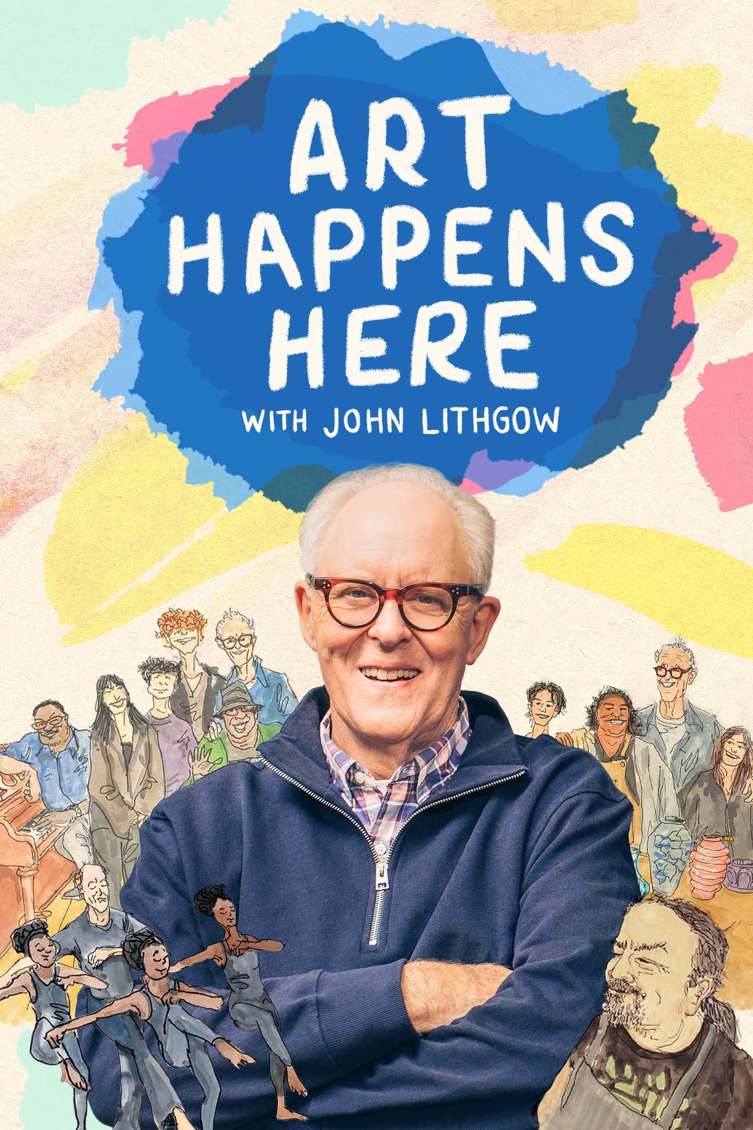
ARLINGTON, VA; Jan. 11, 2024 – In the new PBS special ART HAPPENS HERE WITH JOHN LITHGOW, actor, author, humorist and renowned performer John Lithgow (“Killers of the Flower Moon,” “The Crown,” “The Old Man”) shares his passion for arts education by joining students and teachers at four Los Angeles organizations, diving into four arts disciplines: dance, ceramics, silk-screen printing and vocal jazz ensemble. Celebrating how arts education nurtures and inspires the hearts and minds of students of all ages, ART HAPPENS HERE follows Lithgow as he tries his hand at singing, dancing, printmaking, and pottery, working alongside and learning from young people whose lives are being transformed by art. The one-hour special ART HAPPENS HERE WITH JOHN LITHGOW premieres Friday, April 26, 2024, 10:00–11:00 p.m. ET/PT (check local listings) on PBS, PBS.org and the PBS App.

Growing up, Lithgow wanted to be an artist and was inspired and encouraged by his public school art teachers. As the years have passed, he’s come to see those teachers as his heroes, responsible for instilling him with confidence, curiosity and a sense of self.

“Education involves much more than just the basic academic subjects and preparing kids for being tested and evaluated. Arts education is an anchor that provides a child emotional and social development and a sense of who they are in the world,” says Lithgow. To illustrate his point, Lithgow visits four organizations that are making a difference in the lives of young people: Self Help Graphics & Art, a pioneering Chicano community organization at the intersection of arts and social justice; the Debbie Allen Dance Academy, a nonprofit school offering dance classes to people of all ages; the Community Center of La Cañada Flintridge, home of a nationally renowned ceramics studio; and the Los Angeles County High School for the Arts (LACHSA), a specialized public school open to aspiring young artists throughout Los Angeles County.

As he makes his first pot, collaborates with a young artist on a silk-screen print, learns new dance techniques and gamely joins a group of talented jazz vocal students for a concert, Lithgow revels in the sense of discovery, creativity, and camaraderie that the arts can offer. “The arts give young people tools to move through life. They teach them discipline and hard work, patience and civility. They give young people a sense of empathy. After all, art is about communicating with other people. Through the arts, young people find out who they are and where their imagination will lead them. It happened to me.”

John Lithgow’s roots are in the theater. In 1973, he won a Tony Award two weeks after his Broadway debut in David Storey’s “The Changing Room.” Since then, he has appeared on Broadway 25 times, earning five more Tony nominations, a second Tony, four Drama Desk Awards, and induction into the Theatre Hall of Fame. Lithgow has also appeared in a long list of critically acclaimed films, landing Oscar nominations for “The World According to Garp” and “Terms of Endearment.” Other features have included “All That Jazz,” “Footloose,” “Shrek,” “Interstellar,” “Bombshell” and, more recently, Martin Scorsese’s “Killers of the “Flower Moon” and Edward Berger’s forthcoming “Conclave.” Lithgow has been nominated for 13 Emmy Awards for his work on television. He has won six times: once for an episode of “Amazing Stories,” once for Showtime’s “Dexter,” once for the role of Winston Churchill in Netflix’s “The Crown,” and three times for playing High Commander Dick Solomon on the hit NBC comedy series “3rd Rock from the Sun.” He received his latest Emmy nomination in the HBO television reboot of “Perry Mason” with Matthew Rhys. Currently, he is starring alongside Jeff Bridges in the FX drama series “The Old Man.” In the last three years, Lithgow has joined Kennedy Center President Deborah Rutter and Poet Laureate Natasha Trethewey as co-chairs of a Commission on the Arts for the American Academy of Arts and Sciences. Under their leadership, the Commission has produced authoritative reports on arts in education and America’s creative workforce. The original concept for ART HAPPENS HERE took shape during the Commission’s deliberations.

ART HAPPENS HERE WITH JOHN LITHGOW will be available to stream on all station-branded PBS platforms, including PBS.org and the PBS App, available on iOS, Android, Roku, Apple TV, Amazon Fire TV, Android TV, Samsung Smart TV, Chromecast and VIZIO.

Major funding for ART HAPPENS HERE WITH JOHN LITHGOW was provided by John and Louise Bryson. Additional funding was provided by the California Community Foundation.

The program is produced for PBS by PBS SoCal, in association with Shore View Entertainment, The Watershed Company, Ninetythree Media and Life & Thyme, Inc. Perry Simon, John Lithgow and Juan Devis are executive producers with PBS SoCal’s Tamara Gould serving as Executive in Charge of Production. PBS SoCal’s Angela Boisvert is the producer.

About PBS
PBS, with more than 330 member stations, offers all Americans the opportunity to explore new ideas and new worlds through television and digital content. Each month, PBS reaches over 42 million adults on linear primetime television, more than 15 million users on PBS-owned streaming platforms, and 56 million people view PBS content on social media, inviting them to experience the worlds of science, history, nature, and public affairs; to hear diverse viewpoints; and to take front-row seats to world-class drama and performances. PBS’s broad array of programs has been consistently honored by the industry’s most coveted award competitions. Teachers of children from pre-K through 12th grade turn to PBS LearningMedia for digital content and services that help bring classroom lessons to life. As the number one educational media brand, PBS KIDS helps children 2-8 build critical skills, enabling them to find success in school and life. Delivered through member stations, PBS KIDS offers high-quality content on TV — including a PBS KIDS channel — and streaming free on pbskids.org and the PBS KIDS Video app, games on the PBS KIDS Games app, and in communities across America. More information about PBS is available at PBS.org, one of the leading dot-org websites on the internet, Facebook, Instagram, or through our apps for mobile and connected devices. Specific program information and updates for press are available at pbs.org/pressroom or by following PBS Communications on Twitter.

About PBS SoCal
PBS SoCal uses the power of public media for good, strengthening the civic fabric of Southern California and providing our community with an essential connection to a wider world. As a local, donor/member-supported non-profit organization, PBS SoCal manages 7 channels — including 2 primary broadcast channels, PBS SoCal and PBS SoCal Plus, as well as 5 digital subchannels. With a commitment to make content available anytime and anywhere for free, PBS SoCal reaches nearly 19M viewers in the region with programming that reflects the diversity of Southern California and showcases the full schedule of beloved and trusted PBS content spanning Education, News, Environment and Arts & Culture. PBS SoCal programming is available to viewers over-the-air, on all key streaming platforms via the free PBS App and PBS KIDS App. PBS SoCal also sparks the sharing of ideas at in-person cultural events and community conversations as well as prepares children for kindergarten and beyond by bringing bilingual, hands-on learning experiences to the community for free.

– PBS –

CONTACTS:

Chelsie Pope, PBS
cepope@pbs.org

Cara White / Mary Lugo, CaraMar, Inc.
cara.white@mac.com; lugo@negia.net

JP Shields, PBS SoCal
JPShields@pbssocal.org

For images and additional up-to-date information on this and other PBS programs, visit PBS PressRoom at pbs.org/pressroom.

